How to take Safe Exam Browser Quiz in the course
- Download Safe Exam Browser on the PC (Windows or Mac OS)
iPAD and Android system are not supported
Choose the right download file according to your device operating system

https://safeexambrowser.org/download_en.html
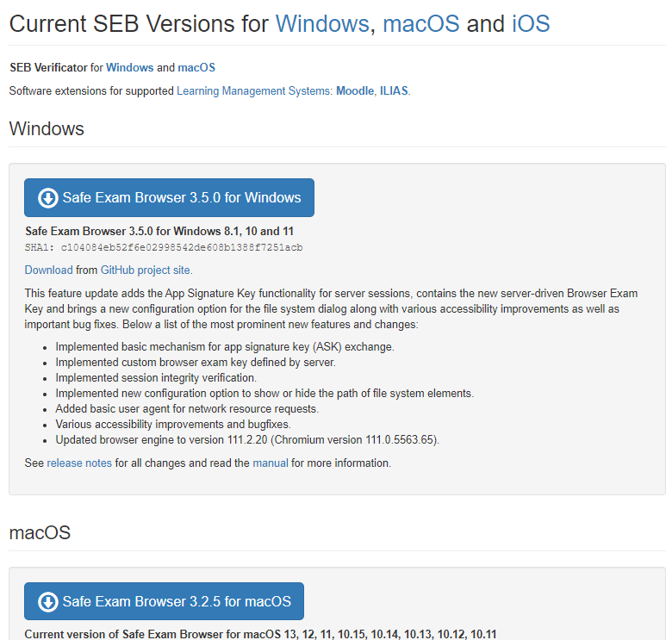

If you have any trouble with installing SEB, contact your counselor or email to Fan -fanw@edu4u.ca

- Click the quiz link
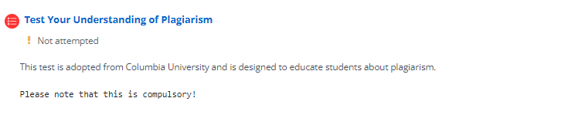
- Launch Safe Exam Browser
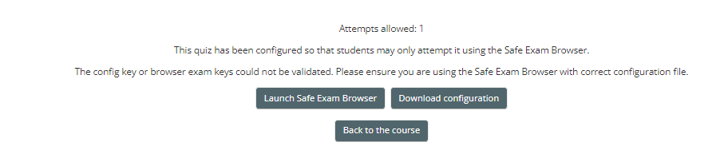
- Login Moodle again

- Following the instruction to complete the quiz

Attempt Quiz Now -> complete each question -> Finish attempt -> Choose “Return to attempt” or “ Submit all and finish” -> Submit all -> Click “” icon to Quit SEB

