Name: Date:
Assignment 4.6



Reducing Food Insecurity
Assignment

Assignment Description:
You have been learning about food security and the impact that food insecurity has on the lives and overall well-being of individuals. For this assignment, you are asked to choose a program, organization, or concept and identify how they are working to reduce food insecurity. Remember that food insecurity is the inability to acquire or consume an adequate diet quality or sufficient quantity of food in socially acceptable ways, or the uncertainty that one will be able to do so.

Choose one of the following programs, organizations or concepts:
-Breakfast club programs (Canada) -community gardens
-Food banks -agricultural co-operatives
-United Nations World Food Programme -urban farming
-Promoting fair trade -Growing Indigenous Businesses
-Empowering women
-Reducing food waste-(eg. France, & Italy) -sustainable farming

Assignment Requirements:
Once you have chosen your program, organization or concept, find out the following pieces of information:
- What is the organization, program, or concept?
- How did the organization, program, or concept come about?
- Can the organization, program, or concept help to reduce food insecurity at the local or global level, or is it a combination of both?
- What are the benefits and drawbacks of the organization, program, or concept?

You will be filling out a graphic organizer using your responses to the above pieces of information. Be sure to write in full sentences, and make sure that your writing is legible and can be read by your classmates.

Grading:
You will be graded for this assignment using a rubric. A level 3 indicates that you have a considerable understanding of the program, organization, or concept, and you make some connections between the program, organization, or concept and the reduction of food insecurity.

Due Dates:
The assignment is due on: June 22& 23, 2021 in class, can be done individually or in pairs. Length: -about 15-20 minutes with at least 3-5 references or more, APA format.

By:

What is the organization, program, or concept?
Describe the organization, program, or concept . . .

How does this organization, program, or concept help to reduce food insecurity?

How did the organization, program, or concept form or come to be?



Benefits:
Drawbacks:

© TeachinginaWonderland 80

Name: Date:
Rubric 4.6

Reducing Food Insecurity Rubric

Level 4 | Level 3 | Level 2 | Level 1
Identification of what the program, organization, or concept is.
The response identifies what the program, organization, or concept is with a high degree of clarity. | The response identifies what the program, organization, or concept is with a considerable degree of clarity. | The response identifies what the program, organization, or concept is with some degree of clarity. | The response identifies what the program, organization, or concept is with a limited degree of clarity.
The response identifies what the program, organization, or concept is with a high degree of thoroughness. | The response identifies what the program, organization, or concept is with a considerable degree of thoroughness. | The response identifies what the program, organization, or concept is with some degree of thoroughness. | The response identifies what the program, organization, or concept is with a limited degree of thoroughness.
Identification of how the program, organization, or concept came about.
The response identifies how the program, organization, or concept came about with a high degree of clarity. | The response identifies how the program, organization, or concept came about with a considerable degree of clarity. | The response identifies how the program, organization, or concept came about with some degree of clarity. | The response identifies how the program, organization, or concept came about with a limited degree of clarity.
Explanation of how the program, organization, or concept can reduce food insecurity.
The response identifies how the program, organization, or concept can help to reduce food insecurity with a high degree of clarity. | The response identifies how the program, organization, or concept can help to reduce food insecurity with a considerable degree of clarity. | The response identifies how the program, organization, or concept can help to reduce food insecurity with some degree of clarity. | The response identifies how the program, organization, or concept can help to reduce food insecurity with a limited degree of clarity.
The response thoroughly identifies whether the program, organization, or concept can reduce food insecurity at the local or global level or both. | The response considerable identifies whether the program, organization, or concept can reduce food insecurity at the local or global level or both. | The response some what identifies whether the program, organization, or concept can reduce food insecurity at the local or global level or both. | The response limitedly identifies whether the program, organization, or concept can reduce food insecurity at the local or global level or both.
Explanation of the drawbacks and benefits of the program, organization, or concept.
The response identifies the benefits and drawbacks of the program, organization, or concept, with a high degree of thoroughness. | The response identifies the benefits and drawbacks of the program, organization, or concept, with a considerable degree of thoroughness. | The response identifies the benefits and drawbacks of the program, organization, or concept, with some degree of thoroughness. | The response identifies the benefits and drawbacks of the program, organization, or concept, with a limited degree of thoroughness.



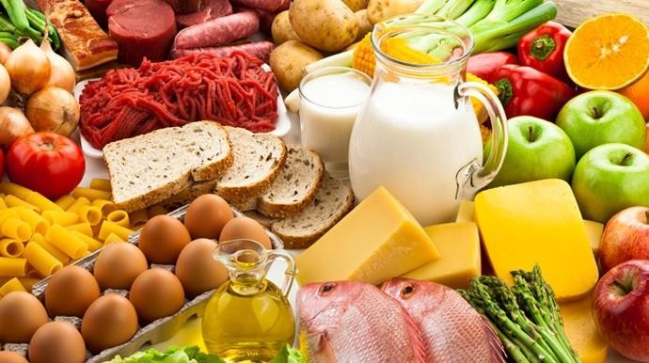
Reflection 4.6

Reducing Food Insecurity
Let’s Think About It:
Food insecurity is the inability to acquire or consume an adequate diet quality or sufficient quantity of food in socially acceptable ways, or the uncertainty that one will be able to do so. Why is it important to reduce food insecurity both at the local and the global level? Which level would be more difficult to reduce food insecurity at?

