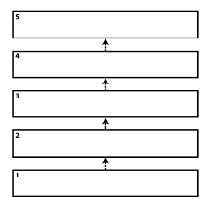What are the steps in a decision making and problem-solving process?
Put them in order.

