Levels of Strategic Planning
Did you know that Coca Cola doesn’t just make Coke but also all the companies below:
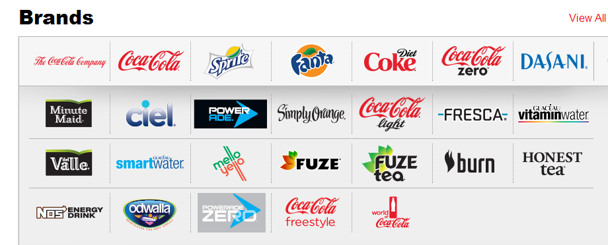
Strategy Level | Description | Main Question
corporate | Sets long-term direction for the organization as a whole, e.g. Coca Cola Company. | In what industries and markets should we compete?
business | Each business unit or product line is often called a strategic business unit (SBU), e.g., Fanta, Sprit, Dasani, SmartWater… | How are we going to compete for customers in this industry and market?
functional | Each business unit has the same basic functional areas or departments, typically these include: human resources, marketing, production, finance, and information technology. | How can we best utilize resources to implement our business strategy?

