CHV2O ~ Civics   
Dropping the writ: how a federal election is called

How does the process of calling an election work?

* The *Canada Elections Act* was amended in 2007 to incorporate fixed-date election legislation and general elections are now to be held on the third Monday of October in the fourth calendar year following the previous election. As a result, the most recent election was for **October 21, 2019**.
* Elections can still be held earlier than scheduled if the government loses the confidence of the legislature. The governor general also retains the ability to dissolve parliament at any time on the advice of the prime minister.
* An election call is also informally known as “dropping the writ.” In order for an election to occur, the Governor General directs the Chief Electoral Officer to issue a formal order that calls for an election to be held.
* While there is no fixed date for when the writs must be issued, the amount of time between the writ drop and election day must be *at least* 36 days. Therefore, [the latest possible day an election could be called](http://ottawacitizen.com/storyline/kady-what-if-they-set-a-fixed-election-date-and-no-one-came) is **Sunday, September 15** for voters to go to the polls on Monday, October 21.

**WHAT IS A WRIT?**

* One writ of election must be issued for each of Canada’s federal ridings. Once all 338 writs have been issued, [copies are sent to each returning officer](http://www.parl.gc.ca/marleaumontpetit/DocumentViewer.aspx?Sec=Ch04&Seq=5&Language=E) (RO), of which there is one per riding. This individual is responsible for administering the election in their riding.
* The returning officer will display this writ in their returning office as public record that an election is underway. After the election, there is a place on the writ to record the election result after counting the votes.
* The election period has officially begun once all 338 writs have been issued and things that must happen during the election period can begin!
* These include the nomination of candidates for election, special rules on the reporting of polls must be observed by the media, advertising by government institutions must cease and campaign spending limits are put in place for parties and candidates.

Question:

1. Using all your course knowledge so far, in a well written paragraph that includes an introductory sentence, 3 pieces of evidence or reasons and a conclusion, answer the following question:

**“Why is it important that a country like Canada has an organized and reliable elections system?”**

Your answer should be 5 to 10 sentences. Remember to proof read before handing in. Due by the end of class.

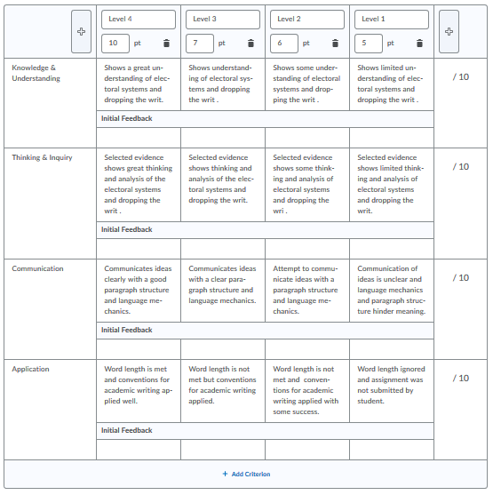Assessment Criteria