A crazy system’: U.S. voters face huge lines and gerrymandering. How Elections Canada makes a world of difference north of the border

SM

By Steve McKinley, Halifax Bureau

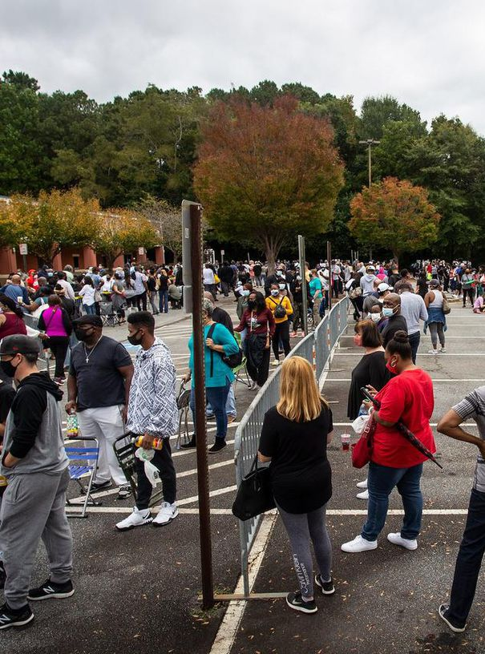Tue., Oct. 13, 2020

9 min. read

Maryland’s 3rd Congressional District sprawls in ungainly fashion across the map, looking, as one U.S. judge reportedly put it, like “a broken-winged pterodactyl lying prostrate across the state.”

It’s also been likened to a blood spatter on a crime scene. Or a praying mantis. Or a Rorschach test.

It’s one of America’s most extreme examples of what’s called gerrymandering — the practice of politicians literally rewriting electoral boundaries to benefit themselves. And it’s merely one instance of how state legislation can sway the running of an American election.

Amid pictures this weekend of hours-long lineups for voters, scrutiny of the [U.S. electoral process](https://www.thestar.com/news/world/uselection.html) and its vagaries may be at an all-time high. Meanwhile, north of the border, Elections Canada, the model of a politically independent electoral agency, is celebrating its 100th anniversary.

Though it has not been immune to occasional political chicanery, the Elections Canada model is currently offering a stark contrast to the U.S. and the accusations of partisanship and voter suppression that have been aimed at its process.

Here are some of the ways the two systems compare.

**America’s ‘laboratories of democracy’**

In Canada, and in most western industrialized countries, a centralized, independent body runs federal elections with the goal of making electoral procedures, including voter access, uniform across the country.

In the U.S., most of the election parameters are decided by 50 individual states, each of which has a slightly different approach.

To some people’s minds, it’s a bizarre way to run an election.

“The United States is a crazy system,” said Mark Rom, associate professor at the McCourt School of Public Policy at Georgetown University.

“There’s a statement made by one of our Supreme Court justices in the past. Justice (Louis) Brandeis said that the states are laboratories of democracy so they can try things out. States can learn from each other and perfect their policies.

“This is clearly completely untrue. Regarding elections, after 200 years of experimentation, our election system is still pretty much a mess.”

North of the border, the task falls to Elections Canada, an independent, non-partisan agency of Parliament. Unlike other departments, Elections Canada does not report to an elected cabinet minister. Instead, it reports to Parliament as a whole.

Its mandate is essentially to ensure that the process of campaigning, obtaining a ballot and voting is exactly the same in St. John’s, Newfoundland, as it is in Victoria, B.C.

While Elections Canada is not immune from political interference, altering its mandate to any significant degree would require changes to the Canada Elections Act, which would require the relatively public process of rewriting legislation.

In the U.S., legislation can be bent to political will at the state level — and has been.

In Florida, after a state constitutional amendment gave released felons the right to vote in the upcoming election, Republican Gov. Ron DeSantis signed off on a law that required those felons to pay all prison fines, fees and restitution before they would be allowed to vote.

As a result, as of last Monday’s deadline for voter registration, less than a quarter of those estimated 1.4 million potential voters had signed up to vote. The demographic most affected by this are Black men.

In Texas, Republican Gov. Gregg Abbott issued an order limiting the number of drop-off locations for mail-in ballots to one per county. That meant that Harris County — which contains Houston and has largely voted Democrat presidentially since Barack Obama in 2008 — had one drop-off location for 4.7 million people in a county that spans 4,600 square kilometres.

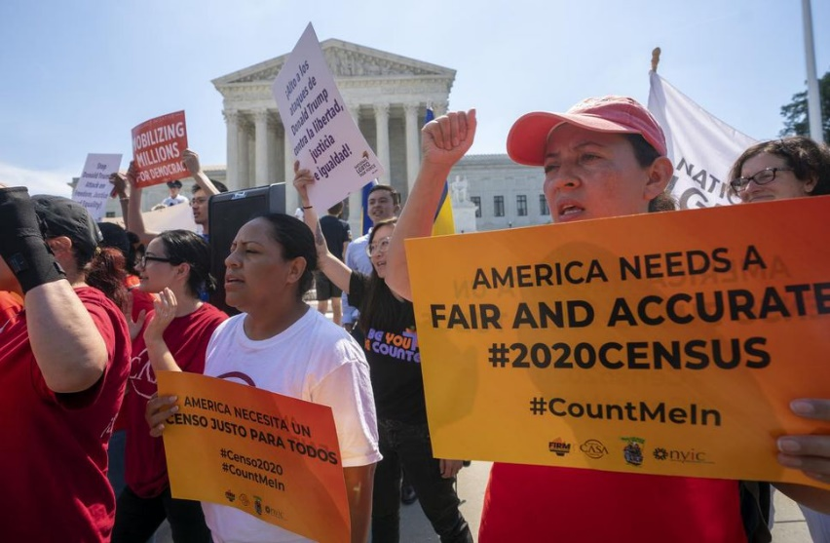Republicans call that “ballot security.” Democrats call it “voter suppression.”

They’re all examples, critics say, of legislators changing the mechanics of an election to tilt the playing field in their favour.

Rom said the U.S. Constitution treats the federal and state governments as almost equals. And while the federal government lays down some strict broad measures about elections — minorities and women can’t be barred from voting, people over the age of 18 can vote, and so on — the actual administration is left to the states.

And that opens the door for some dubious practices, depending on who’s running the state.

Republicans — and in fact most conservative parties — generally benefit more from lower voter turnouts, said Rom.

“In fairness, both parties are doing what they believe to be good for the country. But they’re also doing what they believe to be good for their own partisan interests.”

Nowhere is this more obvious than in the practice of gerrymandering.

**How gerrymandering works**

Samuel Wang is the director of the Princeton Gerrymandering Project. The project uses data analysis to identify and — hopefully — eliminate partisan gerrymandering.

The U.S. census occurs every 10 years. The last was in 2010; the current one is ongoing.

Representation in the U.S. is district-based and, in general, districts in a state have roughly equal population. So following a census, the states use the latest population figures to redraw those boundaries.

That opens the door for abuse, because the people doing the redrawing are state legislators themselves. So, while they keep the populations of districts roughly equal, the borders can be drawn to benefit those legislators.

They’ll do that by “packing” all the opposition party supporters into a few districts — giving the opposition a few big wins, but fewer than would be expected by the state’s general popular vote.

And they’ll do it by “cracking” — spreading the remaining opposition supporters among a large number of districts, so that their voting influence is diluted.

The flurry of district boundary redrawing that occurred after the previous U.S. census, kicked off what Wang calls, “The Great Gerrymander of 2012.”

In 2012, said Wang, more people in the U.S. voted for Democrats than voted for Republicans for Congress — 1.4 million more, to be exact. Yet the eventual totals in Congress were 234 seats for Republicans and 201 for Democrats.

Wang believes gerrymandering had a lot to do with those totals.

“It’s hard to know for sure, but I would say the net effect would be 15 to 20 seats that became safely Republican that would have otherwise either have been Democratic or competitive. Those 15 to 20 seats, could well have made the difference between a Democratic majority and a Republican majority in 2012.”

Changing those practices is difficult, says Wang. Although the Supreme Court has acknowledged the existence of gerrymandering, it has so far declined to intervene.

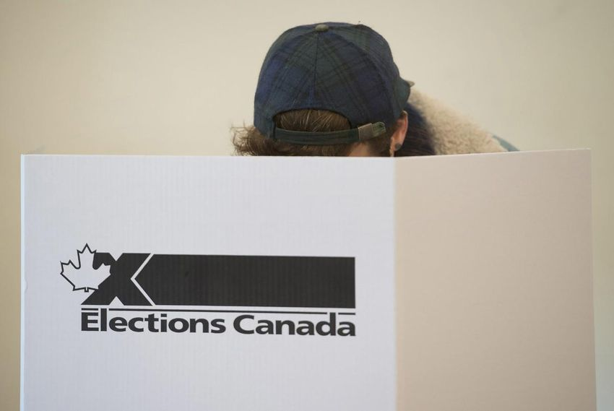**A bid to make the U.S. system a bit more like Canada’s**

At the state level, change would require legislators to act against their own best interests — any politician in a position to change electoral legislation has already benefitted from the status quo.

At the federal level, the majority Democrat Congress has — as its first act — already passed the reform bill HR 1, which is aimed at reducing the influence of money in politics, and protecting and expanding voting rights.

Under the current administration, the bill has no chance of becoming law. Republican Senate Majority Leader Mitch McConnell has refused to bring the bill to the Senate floor, and the president has shown no interest in it.

In the bill is an idea for installing independent, citizen commissions for resetting district boundaries all across the U.S., said Wang. And that could be a step to mitigating partisan gerrymandering.

It would be similar to Canada’s situation, in which that role is taken up by 10 independent Electoral Boundaries Commissions, one for each province.

Every 10 years, after a census, the provinces’ Electoral Boundaries Commissions kick into high gear to adjust the electoral map. Over the next two years, using the data obtained through the census and information gained through public hearings, each Commission submits a proposed electoral map to the House of Commons.

While the commissions will consider objections from members of the House, the final decisions on where those boundaries lie, rests with them.

**Canada’s by the ‘book’ elections**

In similar fashion, when it comes to actually running an election, that task falls to Elections Canada, also an independent and non-partisan agency.

Elections Canada’s mantra is uniformity; from the way political campaigns finance themselves, to the way voters obtain their ballots and how they cast them — it all has to be the same across the country, right down to the way those ballots are counted.

On election night in Canada, when all the voters have gone home, when the polls have closed, when the ballot counting begins, there is no margin for variance. There’s a book to follow, and the book is very specific about how the next few hours shake out.

The book has diagrams to show how to use scissors to open the ballot box. The book says someone has to observe you picking out the ballots. The book says your co-worker must then run their hand around the inside of the box to make sure no ballots get left behind.

One co-worker unfolds the ballot, then hands it to the next, who counts it. They may hold up the ballot to show scrutineers from the political parties if they’re present. But the scrutineers aren’t allowed to touch the ballot, merely to lean in and squint.

“Everybody counts the votes exactly the same way,” said Natasha Gauthier of Elections Canada. “It is literally by the book.”

“There’s a checklist, and the checklist goes in a manila envelope, and then someone checks the checklist to make sure that everything’s been checked off. And then it’s signed and some stuff has to be double-signed by two different people.”

In Canada, on election night, every single polling station in the country counts ballots this way.

And that uniformity applies to all the facets of running an election that Elections Canada manages, Gauthier said.

“Our mandate is to make sure that everybody who can vote is able to vote,” she said.

It’s a system created a hundred years ago — Elections Canada is celebrating its 100th birthday this year — to avoid what Dennis Pilon refers to as a politically mutually assured destruction.

Pilon, an associate professor in the Department of Politics at York University, said the decision was made in this country to fundamentally forswear the use of the electoral process as a political weapon, for fear of those actions damaging all parties concerned.

“What you have in Canada is not so much a depoliticized approach, but an agreement by all parties to essentially put the question beyond politics,” he said. “At some point, the various political players said, ‘You know what? This is too risky to leave this in a totally partisan way. It’s taking up too much of our time fighting over it. So we’re all going to agree to do it this way.’”

**Past controversy**

That’s not to say that attempts have not been made to influence Elections Canada’s actions, said Pilon.

In 2014, just ahead of a 2015 federal election, Stephen Harper’s majority Conservative government passed Bill C-23.

Aside from cutting the agency’s budget — forcing it to abandon a pilot project for online voting — the bill, among other things, stripped Elections Canada of its ability to actively encourage Canadians to vote. It also decreed that, on Election Day, incumbent candidates would appoint polling supervisors, rather than Elections Canada.

But the bill drew massive outrage from the public and opposition parties, even as it passed through Parliament, and in the run-up to the 2015 election, both NDP leader Thomas Mulcair and Liberal leader and future Prime Minister Justin Trudeau vowed to repeal it if elected.

In 2018, Trudeau’s government passed Bill C-76, which walked back many of the provisions of Harper’s Law.

While it’s unlikely that such a law could be passed at a federal level south of the border, undoing a similar law that restricted voter access would require a sequence of events that would only occur with difficulty in the U.S., where changes in voter laws have to be accomplished state by state.

“Our (Canadian) system is not so much the product of some sort of enlightened better angels,” said Pilon. “I think there’s an element to that, of course; it was certainly sold that way. But not too far beneath the surface is a cold, hard partisan battle. And it just happens that the battle was configured quite differently in the United States.”

[Steve McKinley](https://www.thestar.com/authors.mckinley_steve.html)*is a Halifax-based reporter for the Star. Follow him on Twitter:*[*@smckinley1*](https://twitter.com/smckinley1)