**How to take Safe Exam Browser Quiz in the course**

1. **Download Safe Exam Browser on the PC (Windows or Mac OS)**

iPAD and Android system are not supported

Choose the right download file according to your device operating system

https://safeexambrowser.org/download_en.html

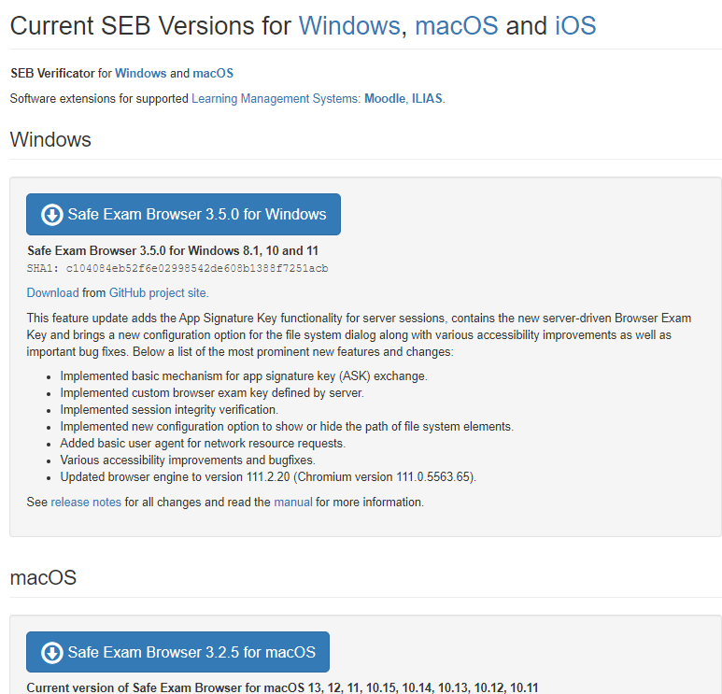

If you have any trouble with installing SEB, contact your counselor or email to Fan -fanw@edu4u.ca

1. **Click the quiz link**

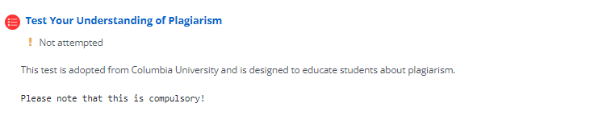

1. **Launch Safe Exam Browser**

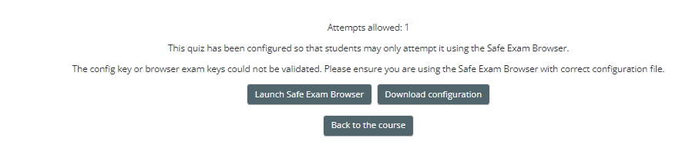

1. **Login Moodle again**
2. **Following the instruction to complete the quiz**

Attempt Quiz Now -> complete each question -> Finish attempt -> Choose “Return to attempt” or “ Submit all and finish” -> Submit all -> Click “” icon to Quit SEB