CHV2O ~ Civics   
Lecture Organizer  
Political Ideology & Spectrum/Compass

Use the following chart to help you take notes most effectively from the PowerPoint presentation.

A is a set of shared ideas or beliefs about the role of government and how society should work.

|  |  |
| --- | --- |
| **Topic/Theme** | **Define the Term** |
| Liberalism |  |
| Conservatism |  |
| Socialism |  |
| Libertarianism |  |
| Capitalism |  |
| Communism |  |
| Fascism |  |

1. List two characteristics of being on the LEFT side of the political spectrum?
2. List two characteristics of being on the RIGHT side of the political spectrum?
3. List two characteristics of being on the UPPER side of the political spectrum?
4. List two characteristics of being on the LOWER side of the political spectrum?
5. According to the Political Spectrum Quiz you took, where did you sit on the Political Spectrum?   
   Do you believe that your placement is an accurate depiction of your political beliefs?  
   *If unable to mark yourself on the spectrum, write the Compass Coordinates below.*

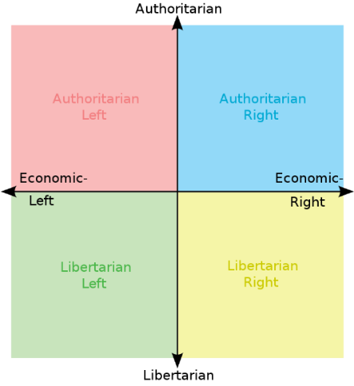 X Axis: Y Axis: