### **Measuring Standards of Living and Income Distribution**

### **1. Understanding Standards of Living**

### **Definition: Refers to the level of wealth, comfort, material goods, and necessities available to a person or society.**

### **Key Indicators:**

### **GDP per Capita: Measures the average economic output per person.**

### **Human Development Index (HDI): Considers life expectancy, education, and per capita income.**

### **Quality of Life Index: Includes health, safety, environmental quality, and access to services.**

### **2. Income Distribution**

### **Definition: How income is spread across a population.**

### **Importance: Reflects economic equality or inequality, influencing social stability and economic growth.**

### 

### 

### 

### 

### **3. Measuring Income Distribution**

### **Lorenz Curve:**

### **What is the Lorenz Curve?**

The **Lorenz Curve** is a **line on a graph** that shows **how income is shared** among people in a country.

### **How It Works:**

* On the **bottom (X-axis)**: We show the **percentage of the population** (from the poorest 0% to the richest 100%).
* On the **side (Y-axis)**: We show the **percentage of total income** that these people have.

### **Two Important Lines:**

1. **Line of Equality (Perfect Fairness):**
   * This is a straight diagonal line.
   * It means **everyone has the same income**.
   * Example: If 50% of people have 50% of the money, that’s perfect equality.
2. **Lorenz Curve (Real Life):**
   * This curve is usually **below the Line of Equality** because **income isn’t shared equally** in real life.
   * The **more the curve bends away** from the Line of Equality, the **bigger the income gap**.

### **✅ Key Idea:**

* **A straight line = Perfect equality** (everyone’s equal).
* **A curved line = Income inequality** (some people have more than others).
* The **bigger the curve**, the **bigger the gap** between rich and poor.

### **How to Plot the Points:**

1. **Start at (0%, 0%)** — no people, no income.
2. **Point 1:** (20%, 5%) → The 20% have 5% of the money.
3. **Point 2:** (40%, 15%) → The 40% (adding the next group) have 15% of the money.
4. **Point 3:** (60%, 30%) → The 60% have 30% of the money.
5. **Point 4:** (80%, 50%) → The 80% have 50% of the money.
6. **Point 5:** (100%, 100%) → All people together have 100% of the money.

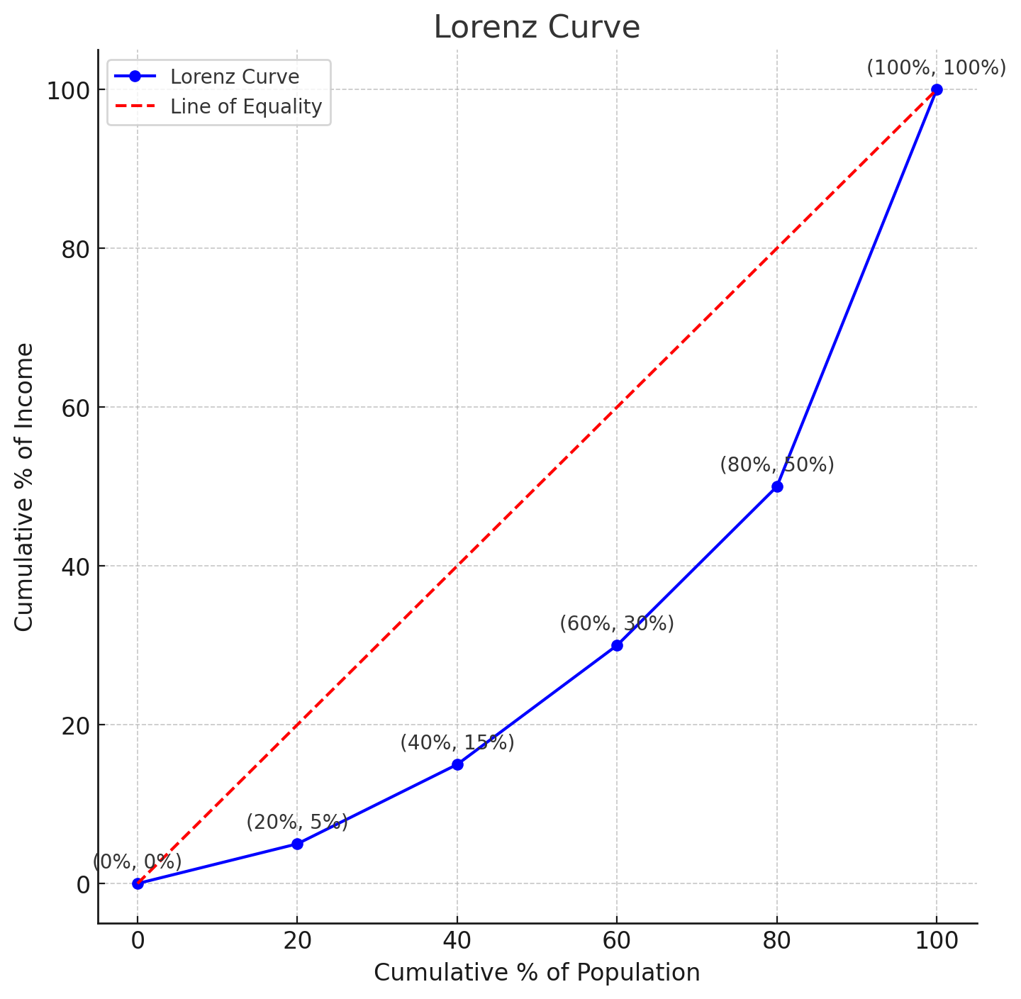

* The **blue line** with dots is the Lorenz Curve. Each dot shows how much income each group of the population has.
* The **red dashed line** is the Line of Equality, where everyone would have the same income.

.

### 

### **Gini Coefficient:**

* A number between **0 and 1** that shows how equal or unequal income is distributed.
* **0 = Perfect Equality:** Everyone has the same income.
* **1 = Perfect Inequality:** One person has all the income, and everyone else has none.
* **Example:** A Gini coefficient of **0.3** means there’s some income inequality, but it’s moderate.

### **Low-Income Cut-Off (LICO):**

* Identifies people who spend **much more of their income on basic needs** (like food, housing, clothing) than the average person.
* Often used in **Canada** to measure **relative poverty** (comparing people’s income to others in society).

### **Market Basket Measure (MBM):**

* Defines poverty based on whether people can afford a “**basket**” of basic goods and services needed for a decent life.
* The **basket** includes **food, housing, transportation, clothing,** and other essentials.
* If a family can’t afford this basket, they are considered **living in poverty**.