I’m Traveling, Even Though I’m Stuck at Home

For the past 30 years, I’ve spent every summer abroad in Europe. Now I’ve realized that traveling isn’t just a pastime—it’s a mindset.

Rick Steves
Travel writer and host of Rick Steves’ Europe

For many people, travel is a way of life. When not on the road, we dream of being on the road. As we fly home from one trip, we’re planning the next. That certainly describes me. And yet, several months into the pandemic, I’ve realized that the essence of traveling requires no passport and no plane ticket. A good traveler can take a trip and never leave her hometown.
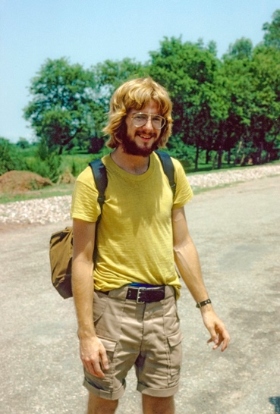
For the past 30 years, I’ve spent four months in Europe each year, writing guidebooks, producing travel television, and leading bus tours. Since mid-March, I’ve slept in the same bed. I’ve eaten dinner at the same table with the same person. A weekly venture to the supermarket is my big excursion. There’s nothing in my pockets, nothing on my calendar, and the only things I’m wearing out are my favorite slippers. I’m home for my first Seattle, Washington summer since 1980.
Stuck here, I’ve been pondering a big question: Why do I travel? When I was young, I sought out vacations on which I could have fun checking iconic sights off my bucket list. As the years went on, I realized that I traveled more to get out of my comfort zone, to find who I was in the immense scheme of things, and to fly home with the best souvenir: a broader perspective.

Since March, I’ve tried to apply this mindset to my current situation. I’ve found that I can satisfy my wanderlust with “sightseeing highlights” just down the street and cultural eurekas that I never appreciated. Before the pandemic, I didn’t think to savor the little, nearby joys in the same way I did while abroad. To be honest, I ignored them. Now I notice the tone of the ferry’s horn, the majesty of my hometown sunset.
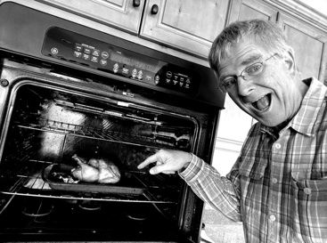
Similarly, while I enjoy sampling new cuisines abroad, I’m lost in my own kitchen. I never cooked until this year—literally never made pasta, never used olive oil, never cared that there are different kinds of potatoes. Now, like someone experiencing the delights of Europe for the first time, I thrill at the sensation of a knife cutting through a crisp onion.

Travelers are free to wonder, seeking inspiration. We marvel at the glorious achievements of the past: ancient Greek philosophy, Renaissance genius, heroic struggles for liberty, equality, brotherhood. While many Americans temporarily cannot visit museums, cathedrals, and monuments, we can be inspired by books, movies, lectures, and conversations. We can explore our backyards like a tourist would. In the past few months, I’ve read the historic plaques in my hometown, wandered through our little cemetery, and admired the church steeple (even if it’s just a painted cross mounted on hardware-store dowels).

I sifted through the brittle I’ve also been dusting off old passions postcards, coated in minuscule handwriting, that I sent home from my earliest backpacking trips. And I oiled up my old trumpet, which had sat in the darkness of its case since I was in college. With each sunset, I play taps from my deck. The neighbors come out, whoop, and clap, and we are reminded—as the sun dips out of sight—that we are in this together and blessed with our health, a beautiful environment, and one another.
This crisis has made me aware of things I’d come to take for granted. For my entire adult life, spending three months each year in Europe has been routine. Now grounded at home, I see clearly how fortunate I was to regularly jet around the world. And reflecting on the suffering this pandemic is causing both near and far, I’m also mindful of my privilege to be able to work from home for a steady paycheck—something I know many do not have right now.
Travel teaches us that there’s more to life than increasing its speed. This quarantine has been therapy for a workaholic like me. Perhaps the pandemic is the universe’s way of telling us all to slow down. And, like travel, this crisis is reminding us of how we need one another, and we need one another to be safe and cared for. Hard times highlight the importance of public services and good governance, as well as the value of neighbors.
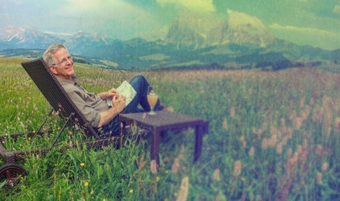
While the future is uncertain, approaching the world as a traveler can make us less afraid. It opens our minds, it opens our hearts, and it enriches our lives. I am confident that, sooner or later, we’ll be planning trips and packing our bags again. In the meantime, I’ll be patient and continue to embrace life with the traveler’s spirit here at home.

On the road, I find myself saying, “Life is good” a lot. And even while homebound during a pandemic, I find plenty to be thankful for—and many reasons to strive for a world where all can say, "Life is good." We can all say the same if we stop to think about it.

