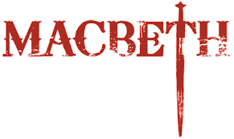

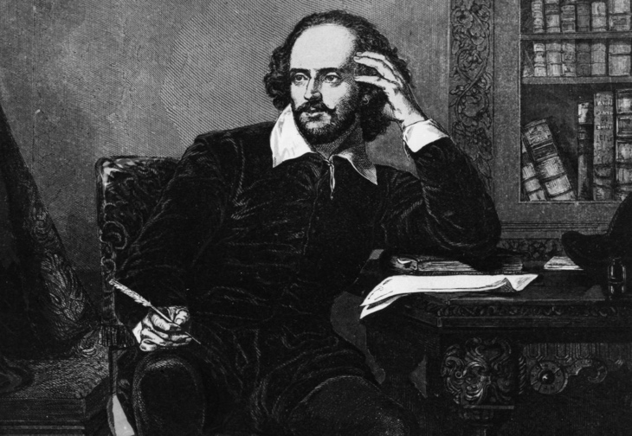

THE FILM VERSION IS DIRECTED BY ROMAN POLANSKI and is linked to a site known as Schooltube which has permission to share it for educational purposes

LINK:
https://www.schooltube.com/media/1_w85ain1g

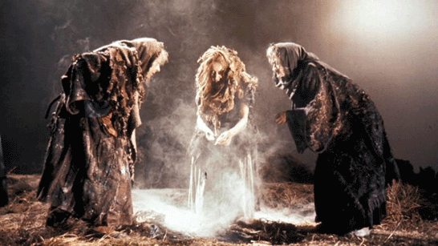
THE STAGE VERSION IS AN ADAPTATION FOR BBC TELEVISION BY THE ROYAL SHAKESPEARE COMPANY and is linked to a site known as the Video Archive for public and educational use.

LINK: (copy and paste)

https://archive.org/details/Macbeth_201510

