ENG3U

Macbeth – Research into Political Assassinations and Executions

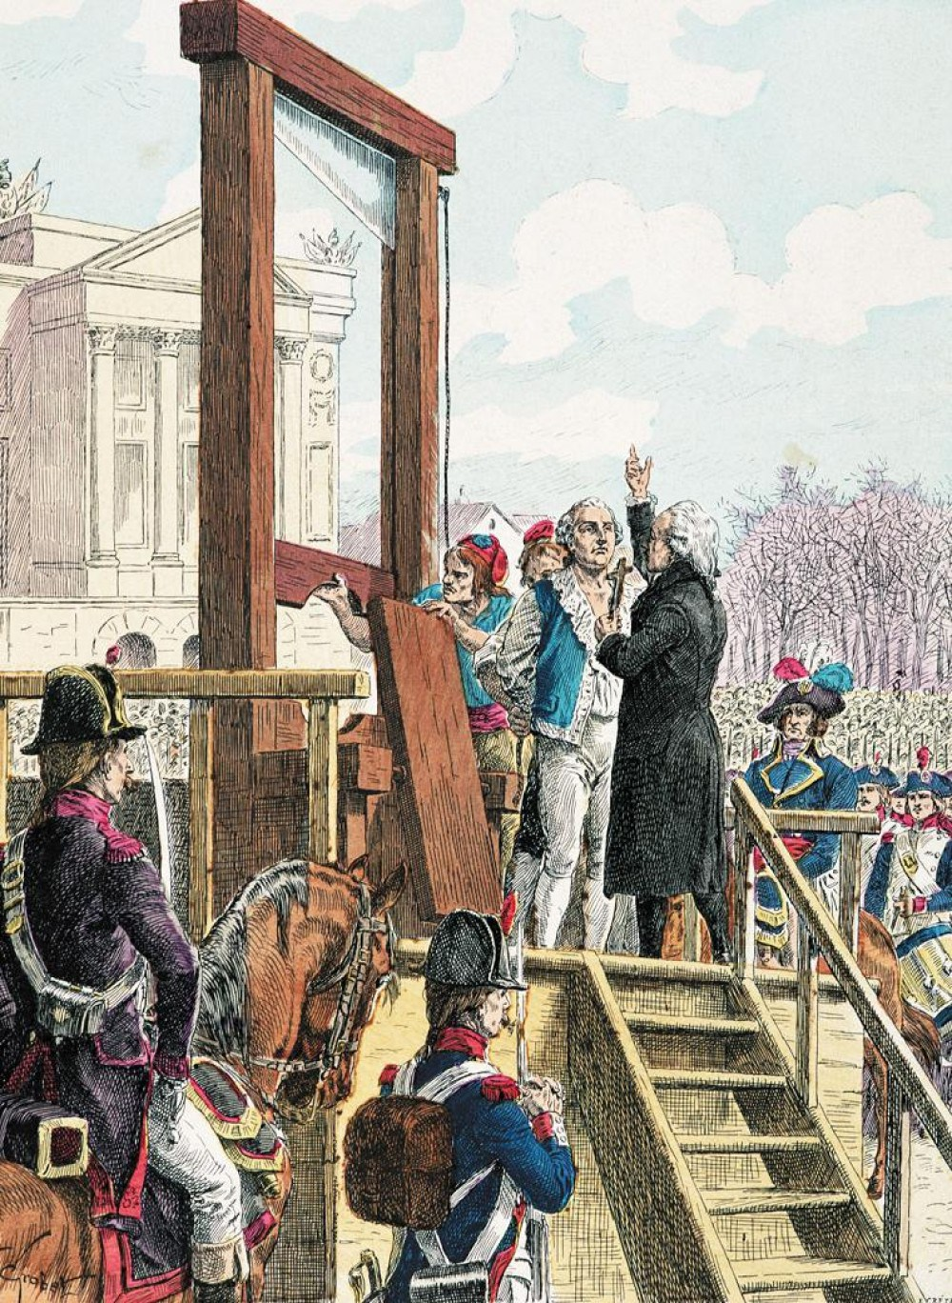

There have been many assassinations and executions of leaders in every nation of the world.

**ASSASSINATIONS**

Czar Nicholas

Anwar Sadat

Abraham Lincoln

John. F. Kennedy

Archduke Ferdinand

**EXECUTIONS**

King Charles 1

King Louis XVI

SOURCE:

<https://en.wikipedia.org/wiki/Li>stofassassinations

Go onto the Internet and fill in the chart

|  |  |  |  |
| --- | --- | --- | --- |
| WHO | WHERE | WHEN | WHY AND HOW |
| Anwar Sadat |  |  |  |
| Abraham Lincoln |  |  |  |
| John F. Kennedy |  |  |  |
| Archduke Ferdinand |  |  |  |
| King Charles 1 |  |  |  |
| King Louis XVI |  |  |  |
| Czar Nicholas |  |  |  |