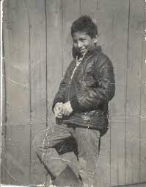
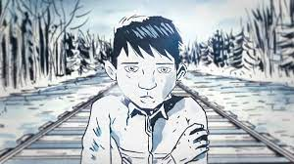
“The Stranger” about the 12-year old boy Chanie Wenjack who ran away from Residential School and froze to death in the Winter.
The Video Link https://www.youtube.com/watch?v=za2VzjkwtFc

The Stranger by Gord Downie
I am a stranger
You can't see me
I am a stranger
Do you know what I mean?
I navigate the mud
I walk above the path
Jumpin' to the right
Then I jump to the left
On a secret path
The one that nobody knows
And I'm moving fast
On the path that nobody knows
And what I'm feelin'
Is anyone's guess
What is in my head
And what's in my chest
I'm not gonna stop
I'm just catching my breath
They're not gonna stop
Please just let me catch my breath
I am the stranger
You can't see me
I am the stranger
Do you know what I mean?
That is not my dad
My dad is not a wild man
Doesn't even drink
My dad, he's not a wild man
On a secret path
The one that nobody knows
And I'm moving fast
On the path that nobody knows

