Lines on the Hockey Rink
There are three types of lines that extend across the width of the playing surface. The center red line divides the rink in half (two 100 foot halves). Two thick blue lines cross the rink 25 feet away from the center line.
This creates a fifty foot neutral zone in between the two blue lines.
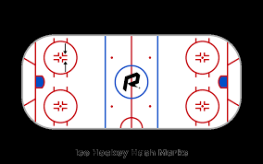
The red lines near the ends of the rink are known as the goal lines.

