CHV2O ~ Civics  
Political Party Posters



Preamble:

In Canadian politics, candidates and elected representatives belong to political parties. These parties shape policy and legislation, steering the nation towards what they feel is important. After learning about the **Political Spectrum**, students learned about the different political parties in Canada. Now that they understand which parties operate in Canada and what they believe in, students will create Political Posters for a party based on a political issue. This will allow students to *apply their knowledge* of the political spectrum and the Canadian political system.

Tasks:

Students will:

1. choose a **Political Party** in Canada.
2. choose a **political issue** in Canada from a provided list.
3. research the issue to find out what their Political Party **has said or believes** about it.
4. create a **colourful and informative poster** (either digital or by hand) that presents their Party’s position about the issue.
5. ensure that all required elements are included on the poster.
6. create a properly formatted bibliography using the Chicago school of citation.

Required Components

All posters must:

1. Include the name of the Party.
2. Include the official logo of the Party.
3. Include at least one direct quotation made by the Party or a member of the Party about the issue.
4. Suggest action (or inaction) based upon the **position** of the Party.
5. Be aligned with the **position** of the Party.
6. Must use appropriate and relevant images that support the Party’s position.
7. Use colours that would be aligned with the Party’s branding.

The Parties:

|  |  |
| --- | --- |
| **Bloc Québécois** |  |
| **Conservative Party** |  |
| **Green Party** |  |
| **Liberal Party** |  |
| **Maverick Party** | EXCLUSIVE: Wexit Canada officially changes name to Maverick Party - The  Western Standard |
| **New Democratic Party** |  |
| **People’s Party of Canada** |  |

**Note: While the Green Party, Maverick Party (Until recently known as the WEXIT party) and the People’s Party of Canada do not currently hold Official Party Status, their existence will likely help shape the political discourse during the next election. As such, they are included, despite not holding Official Party Status.**

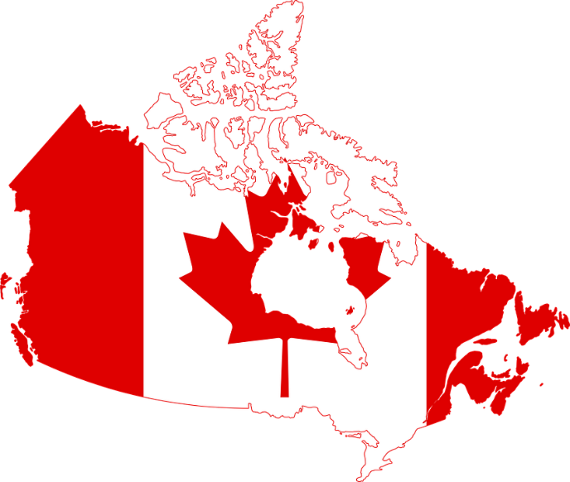Political Issues in Canada

|  |  |  |  |
| --- | --- | --- | --- |
| The Economy: Taxes Government Spending | Health & Pharmacare | Environment & Climate Change | Childcare & Education |
| Indigenous Affairs | Gun Control | COVID-19 | Veterans |
| Gas Pipelines | National Defence | Equality & Diversity | International Trade |
| Electoral Reform | Human Rights | Affordability | Seniors & Pensions |

Advice:

1. In some cases, official websites of the Party might not have the information needed. Students might need to research news articles to find quotations or positions.
2. While students may disagree with the position of the political party, they must still create the poster in a way that is consistent with the Party’s stance.
3. If a student is uncomfortable with the subject matter of their issue, they are encouraged to contact their teacher.
4. Students are encouraged to be creative. Websites such as Canva™, or software such as PowerPoint™, Publisher™ or Photoshop™ are all well suited for this assignment.
5. Bibliographies must follow the **Chicago School of Citation, or MLA, or APA**. Students will be presented with a lesson and reference guide to proper citation. Footnotes are not required for this assignment.
6. Students are encouraged to examine the Political posters and advertisements from our current political parties for inspiration but need to make certain that their work is of their own design.
7. Any promises or declarations must be consistent with the responsibilities & jurisdictions of the Canadian Federal Government, as taught in the Government Structure unit.
8. On the poster, students must provide a solution or action to the issue that is aligned with the Party’s position. Students might need to be creative if a solution has not been proposed yet in the real world.

The Bibliography

Each student must include a Bibliography.

This Bibliography shows the teacher the list of sources used for research and is a part of maintaining Academic Honesty.

Students will be shown how to effectively use the Chicago School of Citation but are also encouraged to contact OWL @ Purdue or their Teacher-Librarian for further assistance and guidance.

Research Notes

Each student will hand in their Research Notes. They will be evaluated on the selection of research sources as well as the information recorded in their notes.

Research notes can be completed in Point form or jot dots. They do not require formal written conventions or paragraphs.

**Student: Party: Election Issue:**

|  |  |  |  |  |  |
| --- | --- | --- | --- | --- | --- |
| Criteria | Below Standard  0-49% | Level 1  50-59% | Level 2  60-69% | Level 3  70-79% | Level 4  80% and up |
| **KNOWLEDGE/ UNDERSTANDING**  - understanding of issue of civic importance using appropriate level of government party position | Off topic or does not present necessary or relevant information or understanding of levels of government  Party platform not used or addressed | Limited understanding of election issue with beginning awareness of level of government  Party Platform used with limited success | Some understanding of election issue with some awareness of level of government  Some aspects of platform used to support debate | Clear understanding of election issue with effective awareness of level of government  Party platform clearly used to support argument | Insightful understanding of issue and levels of government responsibility  Insightful knowledge of platform issues allows for thorough debate points |
| **THINKING**  - explain the political significance of the issue through an analysis of objectives and results  - Solution to issue is measured and aligned with Party | Does not use or reference political significance of the issue  Solution or response to the issue is not provided | Limited use of political significance of the issue through analysis of platform  Solution or response to issue is too simplistic or off-topic | Some use of credible political significance of the issue through analysis of platform  Solution or response to issue shows some thought but is not aligned to the Party position | Use of credible political significance of the issue through analysis of platform  Solution or response to issue shows analysis and connects to the Party position | Persuasive use of political significance of the issue through analysis of platform  Solution or response to issue shows creative analysis and extends beyond the Party position in a genuine way |
| **COMMUNICATION**  - Poster is easy to read and understand  - Language Conventions | Poster is unclear and is difficult to understand  Lapses in Language mechanics distract from meaning | Poster shows limited clarity & cohesion  Lapses in Language mechanics make understanding difficult | Poster shows some clarity and attempt to be cohesive  Attempt made to craft Language mechanics | Poster is clear and cohesive  Language mechanics are sound with error not detracting from meaning | Poster exhibits persuasive clarity and creative cohesion  Sound mechanics show mastery of political terminology and persuasion |
| **APPLICATION**  -Use of appropriate and relevant imagery.  - Cites all sources used in Bibliography  -Research Notes show depth of sources | Bibliography not submitted    Research notes not submitted  Imagery & quotations not included | Bibliography is provided but does not adhere to guidelines.  Research notes show limited selection of sources  Imagery & quotations included but off topic | Some accuracy of sources in Bibliography  Notes show an attempt to source quality sources  Attempt to utilize imagery & quotations is made but ineffective | Effective accuracy of sources in Bibliography  Research notes show varied selection of sources  Imagery & quotations used effectively to support Party position | Highly effective accuracy of sources in Bibliography  Research notes show insightful selection of sources  Imagery & quotations curated creatively to extend Party position with great success |

**Ministry of Education Curricular Connections**

|  |  |  |
| --- | --- | --- |
| **Expectations** | **Learning Goals**  We are learning to... | **Success Criteria** |
| *B2.* ***Governance in Canada:*** *explain, with reference to a range of issues of civic importance, the roles and responsibilities of various institutions, structures, and figures in Canadian governance (FOCUS ON: Stability and Change; Political Perspective)* | - understand the way in which Canada is governed at the local, provincial, national and global levels of government and how that impacts policy decisions | * I can explore an issue of civic importance and identification of the appropriate level(s) of government * I can identify the relevant political perspectives for this issue and make compelling oral arguments for and against a position |
| *B3.* ***Rights and Responsibilities:*** *analyse key rights and responsibilities associated with citizenship, in both the Canadian and global context, and some ways in which these rights are protected. Focus on: Political Significance; Objectives & Results* | - analyse the key rights and responsibilities associated with citizenship and understand how they impact policy decisions | * I can explain why this issue is or is not important to me and understand that it may have a different level of importance to others * I can explain the political significance (using criteria) of my specific “side” of the issue through an analysis of objectives and results |
| A1.2 *select and organize relevant evidence, data, and information on issues, events, and/or developments of civic importance from a variety of primary and secondary source ensuring that their sources reflect multiple perspectives* | - use primary and secondary sources in creating arguments | * I can consult primary and secondary sources in researching an issue to ensure that my oral arguments reflect multiple perspectives and keep a record * I can effectively present my “side” with clear arguments and evidence, in an oral debate and refute the “other side’s” arguments respectfully |
| *A1.6 evaluate and synthesize their findings to formulate conclusions and/or make informed judgements or predictions about the issues, events, and/or developments they are investigating* | - evaluate research material and form conclusions about issues | * I can consult credible sources on both sides in crafting my arguments * I can make judgements about what are the stronger and weaker arguments for my position |
| *A1.7 communicate their ideas, arguments, and conclusions using various formats and styles, as appropriate for the intended audiences and purpose* | - communicate ideas effectively in oral debate and written reflections | * I can communicate clearly in a debate format with opening statement, arguments for/against, free-flow debate refuting opposing arguments and closing argument |
| *A1.8 use accepted forms of documentation to acknowledge different types of sources* | - cite sources properly in written and oral presentations | * I can cite all sources used accurately in a written Bibliography in proper Chicago format |

*Adapted from materials provided by the Civics With WE Service Writing Team, 2017*