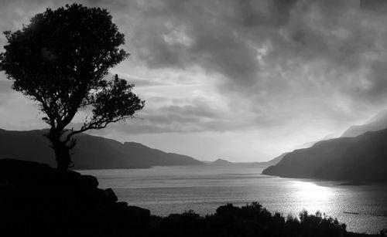

The Lake Isle of Innisfree by William Butler Yeats

This poem was written in 1908. W.B Yeats was Irish and one of the most revered and best known poets of the English language.

Innisfree is located in Ireland, but Yeats was living in England at the time he wrote this.

I will arise and go now, and go to Innisfree  
 And a small cabin build there, of clay and wattles*[1] made *see definition below

Nine bean rows will I have there, a hive for the honeybee,

And live alone in the bee-loud glade.

And I shall have some peace there, for peace comes dropping slow,

Dropping from the veils of the morning to where the cricket sings

There midnight's all a-glimmer[2] and noon a purple glow,

And evening's full of the linnet's[3] wings.

I will arise and go now, for always night and day

I hear lake water lapping with low sounds by the shore

While I stand on the roadway, or on the pavements grey,

I hear it in the deep heart's core.

1. Wattles – Wooden poles, intertwined with thin branches to form a wall or roof.
2. Glimmer – flicker of light (here used to mean the twinkle of stars)
3. Linnet – a small songbird, once commonly kept as a cage bird because of its beautiful singing.