ESP3O

Miss Molliconi

FEEDBACK for _________________

**Assignment 1: Recitation**

**Peer-Assessment**

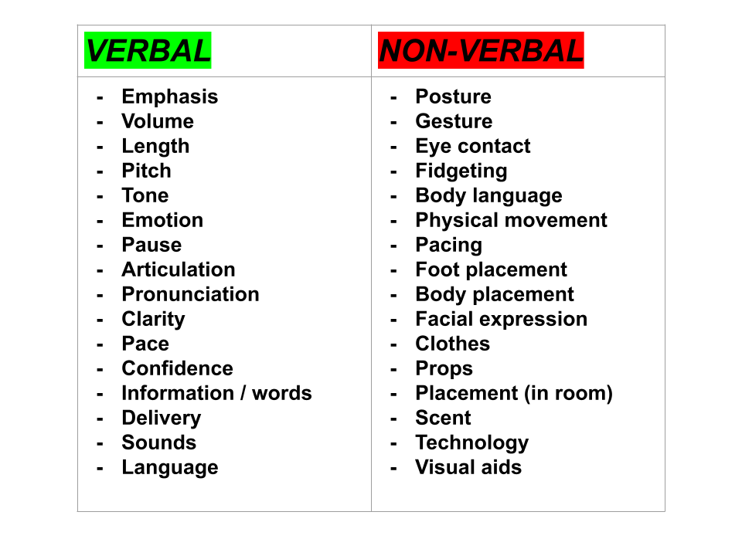

**Feedback (what have they done well?):**

**Feed-forward (how can they improve?):**