ESP3O

Miss Molliconi

FEEDBACK for _________________

**Assignment 1: Recitation**

**Self-Assessment**

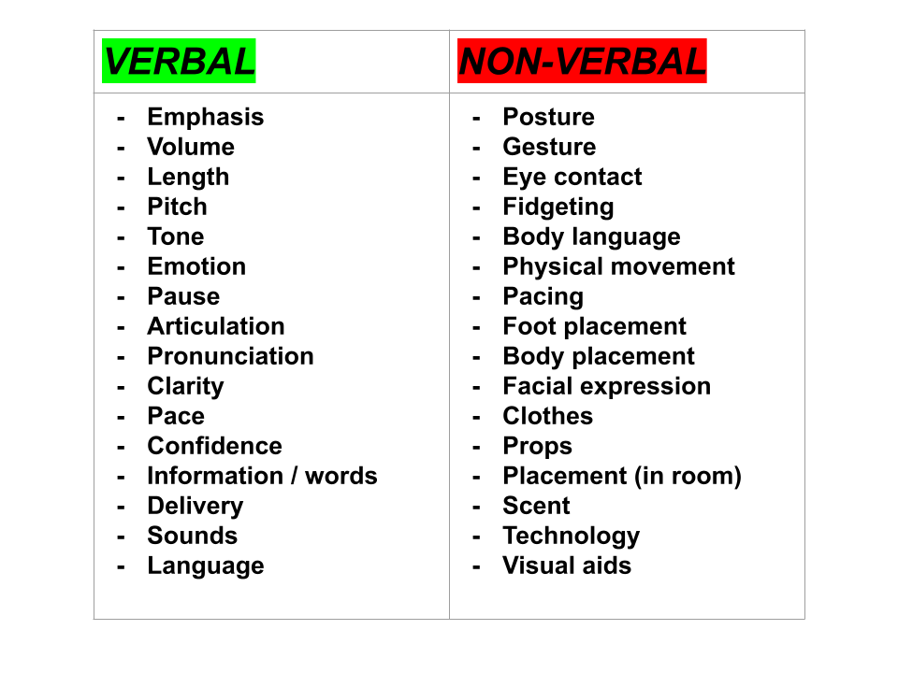

**Feedback (what have YOU done well?):**

**Feed-forward (how can YOU improve?):**

**Pupil Response (what is ONE thing you will improve on your next presentation?):**