ESP3O

Miss Molliconi

FEEDBACK for _________________

**Assignment 2: PowerPoint Presentation**

**Self-Assessment**

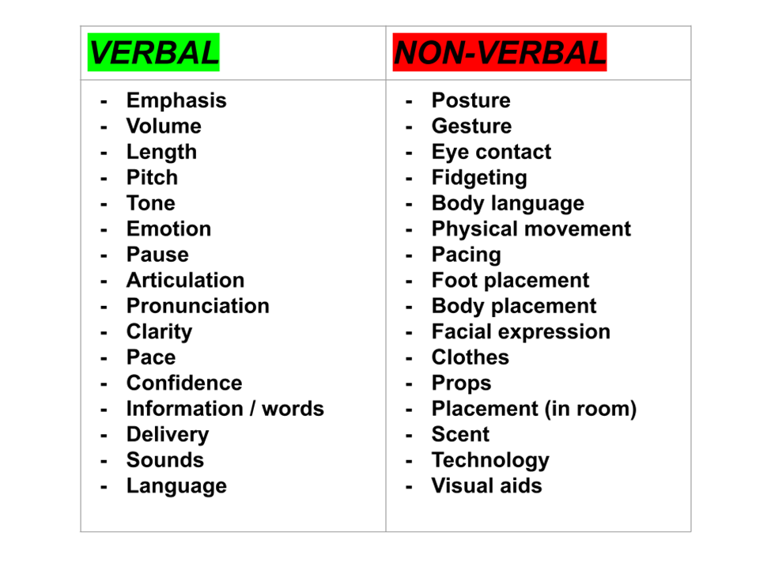

Use the following list of **success criteria** to help you complete the self-assessment:

* Presentation focuses on the correct topic (self-introduction)
* Presentation includes any combination of the **seven** subtopics listed on the assignment 2 document (i.e. basic information, family background, future goals and aspirations, etc.)
* Presentation is between **3-4 minutes**
* Effective **Powerpoint slide design** (i.e. visually appealing, concise, organized)
* Effective use of **emphasis** (pitch, volume, length) and **pause**
* Effective use of **verbal** communication
* Effective use of **non-verbal** communication

**Feedback (what have you done well?):**

**Feed-forward (how can you improve?):**

**Pupil Response (what is ONE thing you will improve on your next presentation?):**