**How to Use PowToon**

**Step 1: Make an account and log in at** [**www.powtoon.com**](http://www.powtoon.com)

**Step 2: Click “blank” under the create button.**

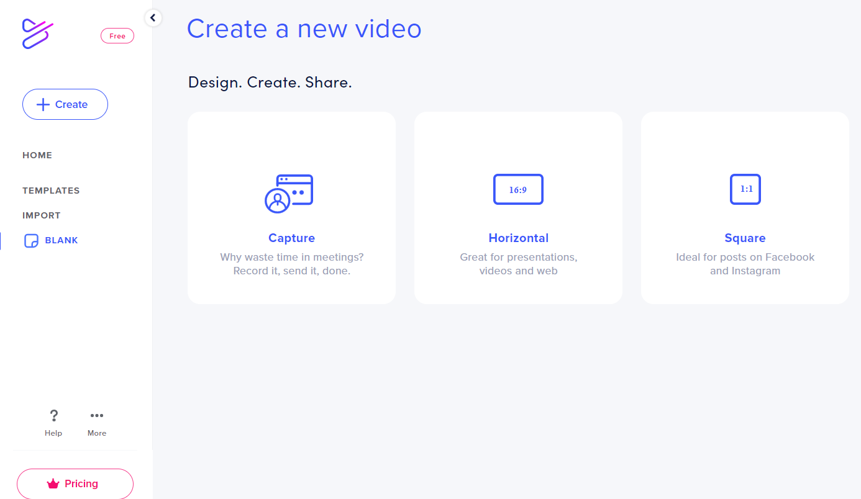



**Step 3: Use the menu on the right to add things to your slide.**

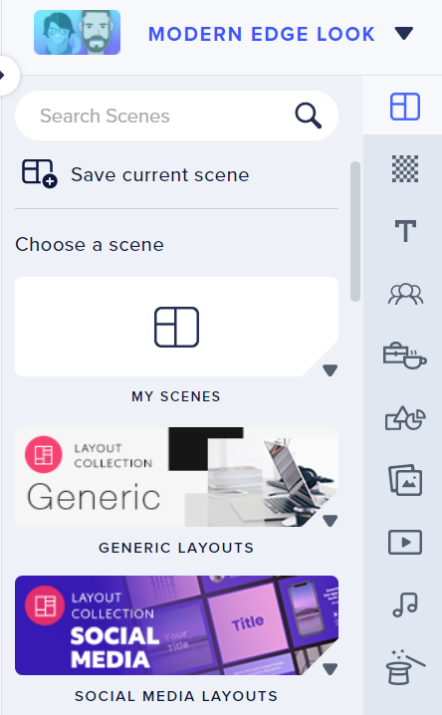



Record audio for a slide

Add a video

Add images

Add background images

Add shapes

Add props

Add characters (scroll to the bottom for the free one)

Add text box

Add a scene (template design)

For free characters, click on characters and then find “The Office”:

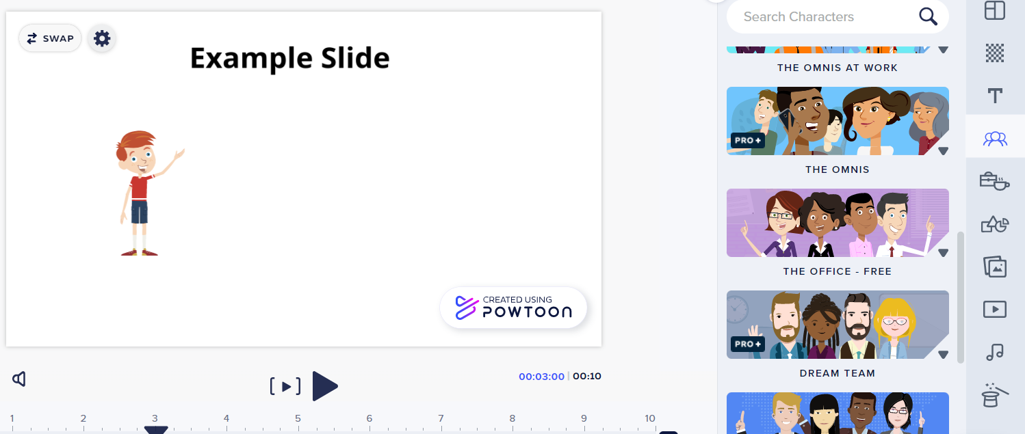



To add your voice to a slide, click on Audio and then Add a Voiceover.

