Question:

***Staple Foods of the World***

Staple foods are derived either from vegetables or animal products, and common staples include cereals such as rice, wheat, maize, millet, and sorghum; starchy tubers or root vegetables such as potatoes, cassava, sweet potatoes, yams, or taro; and meat, fish, eggs, milk, and cheese.

**Staple Food: Wheat**

Thirty-five percent of the world's population relies on wheat as its main staple food. Wheat is the primary cereal grain of the world's richest countries. New strains of wheat are being developed constantly, and now wheat is gaining ground in the developing world. The total amount of wheat grown in the world has doubled in the last few decades. Wheat is very high in nutrition and is easy to store and transport. Wheat was first domesticated in the Middle East, in the area known as the Cradle of Civilization near what is now Iraq. Domesticating this reliable, versatile staple food was key to the development of agriculture. Wheat grows well in temperate climates, even those with a short growing season. The main producers of wheat are China, the United States, India, France, Canada, Turkey, Russia, the United Kingdom, and Pakistan. The majority of breads are made with wheat flour. Wheat flour is also used in pasta, pastries, crackers, breakfast cereals, and noodles. Wheat can be crushed into bulgur, which has a high nutritional value and is often used in soups and pastries in the Middle East.

**Preparing foods made from wheat** ~~~~~~~~~~~~~~~~~~~~~~~~~~~~~~~~~~~~~~~~~~~~

**Tabbouleh (Lebanon)**

One Arab version has it that the tree of knowledge in the Garden of Eden was not an apple tree at all, but a huge stalk of wheat, so wide that the serpent placed in guard could not encircle it. In desperation the reptile persuaded Eve to prune the plant and, in passing, offer some of the grain to Adam. And in this way the couple incurred God’s wrath. The tale has a twist though, for the wheat that caused their downfall inside the garden become their mainstay outside it, and the wheat berry is still highly regarded in the Arab world.

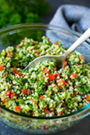*Ingredients:*

225 g **bulgur**or prepared cracked wheat –1 cup

450 g tomatoes, cubed – 1lb.

1 medium onion, finely sliced –1

Handful of fresh parsley, chopped

Handful of fresh mint, chopped

90 mL of olive oil—6 tbsp.

Juice of 2-3 lemons, to taste

150 g black or green olives –1 cup

Salt and pepper

*Directions:*

1.      Take a salad bowl and put in the bulgur or cracked wheat, chopped tomatoes and onion together with the parsley and mint

2.      In another bowl, beat the oil and the lemon juice and season with salt and pepper. Then pour it over the salad and mix thoroughly

3.      Put the olives on top and then chill the salad in the refrigerator for about 2 hours before serving. Garnish with a little more parsley and chopped tomato, if desired.

~~~~~~~~~~~~~~~~~~~~~~~~~~~~~~~~~~~~~~~~~~~~~~~~~~~~~~~~~~~~~~~~~~~~~~~~

**Irish Soda Bread**

Since soda bread is a quick bread, not a yeast bread, it is quick and easy to make. It is rugged and grainy, perfect with meal-size salads, soups, and stews.

*Ingredients:*

               250 mL all purpose flour—1 cup

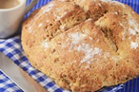               250 mL whole wheat flour –1 cup

               5 mL baking powder –1 tsp.

               5 mL baking soda –1 tsp.

               10 mL granulated sugar –2 tsp.

2 mL salt—1/2 tsp.

25 mL butter—2 tbsp.

250 mL sour milk or buttermilk –1 cup

Directions:

1.      In a mixing bowl, combine flours, baking powder, baking soda, sugar, and salt

2.      With pastry blender or 2 knives, cut in butter until mixture resembles fine crumbs

3.      Stir in sour milk, all at once, to make a soft sough (a little sticky)

4.      Turn out onto lightly floured surface. Knead about 10 times. Form into ball. Place on non-stick baking sheet. Flatten into 7.5cm (3-inch) thick round. With sharp knife, cut large X about 5 mm (1/4 inch) deep in top of dough.

5.      Bake in 190C oven for about 40 minutes or until golden brown

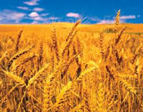

~~~~~~~~~~~~~~~~~~~~~~~~~~~~~~~~~~~~~~~~~~~~~~~~~~~~~~~~~~~~~~~~~~~~~~~~

***Staple Food: Corn***

Corn is the second largest cereal crop in the world. When the Spanish explorers first came to Mexico, they were astounded by the bountiful corn grown there by the Maya and Aztec peoples. Maize, another name for corn, is the only cereal crop of American origin. In many parts of Africa, corn is also a staple food. However, corn is low in protein and a heavy dependence on it can lead to nutritional deficiency. The United States is the world’s largest corn grower, producing more than 40 percent of the world’s corn. China, Brazil, Mexico, France, Argentina, and South Africa also produce large amounts of corn.

Corn is used in a variety of ways, and can be stored relatively easily. This is why it is such a popular food staple. Dried, ground corn is called cornmeal. Many cultures make porridge out of cornmeal, including polenta in Italy and sadza in Zimbabwe. Cornmeal is also used to make cornbread, or treated with limewater to make masa, the main ingredient in tortillas.

Corn kernels can be soaked in lye to produce hominy. Coarsely ground hominy is used to make grits, a popular food in the southeastern United States. Grits are a popular breakfast food, as are corn flakes and other cereals made from corn. Brazilians make a dessert called canjica by boiling corn kernels in sweetened milk. In the Americas and the United Kingdom, many people like to boil, grill, or roast whole ears of corn and simply eat the kernels off the cob. Cooked kernels may also be removed from the cob and served as a vegetable. Certain varieties of corn kernels, when dried, will explode when heated, producing popcorn.

Corn is also used to produce corn oil, sweeteners such as corn syrup, and cornstarch, which is used as a sweetener and thickening agent in home cooking and processed food products. Alcohol from fermented corn is the source of bourbon whiskey.

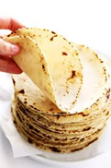**Preparing foods made from corn**~~~~~~~~~~~~~~~~~~~~~~~~~~~~~~~~~~~~~~~~~~~~~~

**Cornmeal Tortillas**

*Ingredients*:

1 egg—1

250 mL water—1 cup

125 mL all-purpose flour—1/2 cup

75 mL cornmeal—1/3 cup

2 mL each baking powder and salt—1/2 tsp.

*Directions*:

1.      In a bowl, whisk egg and water. Beat in flour, cornmeal, baking powder, and salt. Set aside for 10 minutes.

2.      Heat non-stick 17.5cm skillet over medium heat. Brush very lightly with vegetable oil.

3.      Stir batter, then pour batter, 25 mL (2 tbsp.) at a time, into skillet to make very think pancakes. Cook just until dry on top. Do not turn. Stack until all pancakes are cooked. Stir batter as it is being used since cornmeal settles to the bottom.

~~~~~~~~~~~~~~~~~~~~~~~~~~~~~~~~~~~~~~~~~~~~~~~~~~~~~~~~~~~~~~~~~~~~~~~~

**Pastel de Chocolo—Corn/Maize Pie with Chicken (Chile)**

Variations of this pie are found in Bolivia and other Latin American countries. Corn or maize is the only major cereal grain native to the Americas. In North America, it was introduced to the colonists by the Iroquois Indians. Among the many varieties is the distinctly flavored blue corn, grown in Arizona and New Mexico by the Hopi Indians.

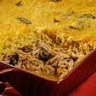 *Ingredients:*

1.5 kg chicken, skinned and cut into portions—3 lbs.

25 mL oil –2 tbsp.

2 onions, chopped –2

5 mL ground cumin—1 tsp.

5 mL dried marjoram—1 tsp.

15 mL flour –1 tbsp.

300 mL stock or water—1 ¼ cups

50 g raisins or sultanas –1/4 cup

75 g olives, cut in halves –1/3 cup

2 hard-boiled eggs, sliced –2

2 eggs, beaten

180 mL milk—3/4 cup

1 medium can corn kernels –1

5 mL sugar –1 tsp.

Salt and pepper

*Directions*:

1.      First, place chicken portions into large pan and pour in just enough water to cover. Put a lid on pan and bring it to a boil. Then lower hear and simmer for 30-40 minutes or until chicken is cooked.

2.      Life out the chicken pieces, keeping the stock, and allow them to cool. Remove the meat from the bones.

3.      Now heat the oil in a pan and sauté the onions for a few minutes before adding the cumin and marjoram. Cook for 2 minutes

4.      After that, slowly add the stock or water, stirring constantly so that you get a smooth sauce. Bring this to a boil and then put it in the chicken pieces, seasoning with salt and pepper

5.      Next, spoon the chicken mixture in an oven-proof dish and scatter the raisons or sultans, sliced olives, and hard-boiled eggs on top

6.      Then whisk the beaten eggs and milk together in a bowl, adding the corn. Pour this over the chicken and sprinkle the sugar on top. Bake in the oven for 45 minutes or until the topping is set. Serve with baked potatoes and salad.

~~~~~~~~~~~~~~~~~~~~~~~~~~~~~~~~~~~~~~~~~~~~~~~~~~~~~~~~~~~~~~~~~~~~~~~~

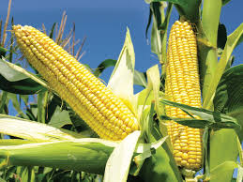

***Staple Food: Rice***

 Rice is one of the world's oldest and most important staple foods. There are over 7000 varieties of rice grown around the world today. Rice is a food staple for more than 3.5 billion people around the world, particularly in Asia, Latin America, and parts of Africa. Rice has been cultivated in Asia for thousands of years. Scientists believe people first domesticated rice in India or Southeast Asia. Rice arrived in Japan in about 3,000 years ago. The Portuguese most likely introduced it into South America in the 16th century.

 All rice is brown to start with; then the bran layer is stripped, and the rice is polished to make it white. It has less protein than most of the other cereal grains and provides mainly carbohydrates. Today, the world’s largest rice producers are China, India, and Indonesia. Outside of Asia, Brazil is the largest rice producer. Rice grows in warm, wet climates. It thrives in waterlogged soil, such as in the flood plains of Asian rivers like the Ganges and the Mekong. "Deepwater rice" is a variety of rice that is adapted to deep flooding, and is grown in eastern Pakistan, Vietnam, and Burma.

**Preparing foods made from rice**~~~~~~~~~~~~~~~~~~~~~~~~~~~~~~~~~~~~~~~~~~~~~~

**South Indian Biryani**

This biryani uses cardamoms, which are native to the hills of South India and Sri Lanka. Cardamom is related to the ginger family and is now somethings grown between rows of tea bushes, or rubber trees on the plantations. First mentioned in European literature in the 12th century, cardamom has long been an important spice, the seeds from its dried pods lending delicate fragrance to curries and desserts.

*Ingredients:*

900 g beef, chicken, or lamb cut into small chunks—2 lbs.

5 mL 1 green chili, crushed or chili powder –1 tsp.

1 large tomato, cut finely—1

10 mL handful of fresh parsley or mint, chopped or dried

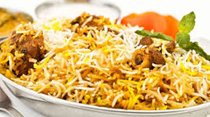5 mL turmeric –1 tsp.

125 mL yogurt –1/2 cup

2.5 cm ginger root, peeled and grated

5 mL ground ginger

900 mL water—4 cups

400 g rice –2 cups

40g oil –3 tbsp.

40 g margarine –3 tbsp.

10 mL 2 sticks cinnamon –2 tsp.

2 seeds from 2 cardamom pods, crushed—2

5-10 curry leaves –5-10

3 large onions –3

10 mL garam masala—2 tsp.

110 g black or other lentils, cooked until tender—1/2 cup

Directions:

1.      Put the meat in a bowl and add the chili, tomato, mint or parsley, turmeric, yogurt, salt, ginger, and garlic. Leave it to marinate for 1 hour

2.      In a heavy pan, heat the oil and margarine together and cook the cinnamon, crushed cardamom, curry leaves and onions until golden brown. Keep some of the onion rings to use later to decorate the dish

3.      When it is ready, add the meat and its marindafe and cook on a low heat until the meat is nearly tender. It does not need to be completely cooked since it will cook some more in the oven (below)

4.      Bring the water to a boil in a large pan, adding a little salt, and cook the rice for 5 minutes if using white rice, 10 minutes of using brown. When the rice is ready, set aside.

5.      Put the garam masala and cooked lentils into the pan containing the meat and simmer for a further 10 minutes

6.      At the end of this time, transfer the mixture to an oven-proof dish and add the rice, stirring to combine the ingredients

7.      Garnish with the onion rings and place the dish in the oven for 30 minutes or so. The cooking of all the foods will be done.

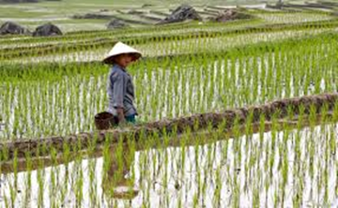

**Staple Foods: Millet, Potatoes, Sorghum**

Staple Foods: Millet

 Millet is the most ancient of the grains that are still grown today. It grows well in areas that are subject to droughts, and has sustained people who would otherwise have been victims of famine. Millet can grow in conditions of poor soil and very little rainfall. It is easy to store, and can even be stored for many years;

this also helps to prevent food shortages in drought-ravaged areas of the world. Millet is usually cooked as porridge and made into a flat bread. It is one of the basic foods for over 400 million people in India, Africa, and China. The main producers of millet are India, China, Nigeria, Niger, Russia, Senegal, and Egypt.

**Preparing foods made from millet**~~~~~~~~~~~~~~~~~~~~~~~~~~~~~~~~~~~~~~~~~~~~~

**Millet and Lentil Bake (Iran)**

*Ingredients:*

250 mL red lentils—1 cup

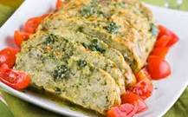250 mL millet, soaked—1 cup

25 mL oil –2 tbsp.

3 cloves garlic, crushed –3

1 onion, chopped –1

1.4 L stock –6 cups

5 cloves—5

3 seeds from 3 cardamom—3

3 mL ground cinnamon ---1/2 tsp.

2 bay leaves –2

Salt and pepper

*Directions:*

1.      A large cooking pot suitable for top of the stove and the inside of the oven. Start by heating the oil in the pot and then soften the garlic and onion in it

2.      After that, add the millet together with the stock, cloves, cardamom seeds, cinnamon, and bay leaves and bring to a boil. Turn down the heat, cover the pot and simmer for 1 hour

3.      Put in the lentils and cook for a further 15 minutes, until they and the millet are ready

4.      When this is done, pour off any remaining liquid. Replace the cover, put the pot into the oven and let cook for 15-20 minutes until the moisture has been absorbed.

~~~~~~~~~~~~~~~~~~~~~~~~~~~~~~~~~~~~~~~~~~~~~~~~~~~~~~~~~~~~~~~~~~~~~~~~

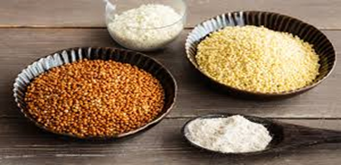

**Staple Foods: Potatoes**

 The Irish were the first Europeans to use the potato as a staple food. They liked it because it was hardy, quick to grow, used less land, and was less labour intensive than growing grains. Since potatoes grew underground, they were less likely to be stomped on by their enemies. Since the potato was rich in nutrients and easy to grow, it became a staple food for the poor in Ireland and other parts Of Europe in the 17th century. Unfortunately, the potato is also susceptible to disease, and the potato blight that hit Ireland in the mid 1800s led to the deaths by starvation of more

 than a million people. Today, the potato remains a favourite, nutritious, and still relatively cheap staple food all over the world. Main producers of potatoes are Russia, China, Poland, the United States, India, Germany, France, and the United Kingdom.

**Preparing foods made with Potatoes**~~~~~~~~~~~~~~~~~~~~~~~~~~~~~~~~~~~~~~~~~~~

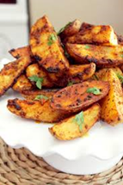**Curried Potato Fries (India)**

*Ingredients:*

4 medium potatoes –4

2 mL turmeric –1/2 tsp.

15 mL sesame seeds, toasted –1 tbsp.

1-2 cloves garlic, crushed—1-2

Oil for frying

Salt to taste

*Directions:*

1.      Begin by cutting the potatoes into French fry shapes and then soak them in water for 30 minutes. Drain them and leave to dry.

2.      After this, heat enough oil to shallow fry. Add the potatoes and salt cook for 15 minutes

3.      Next, add the turmeric and mix it well to spread the color evenly

4.      When the potatoes are nearly done, put in the crushed garlic and toasted sesame seeds. Mix well and then serve with dhal (cooked lentils) or as a snack

~~~~~~~~~~~~~~~~~~~~~~~~~~~~~~~~~~~~~~~~~~~~~~~~~~~~~~~~~~~~~~~~~~~~~~~~

**Latkes—Jewish Potato Pancakes**

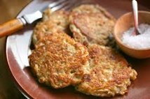Ingredients:

2 large potatoes, unpeeled and scrubbed—2

1 small onion—1

2 egg whites—2

15 mL all-purpose flour—1 tbsp.

5 mL salt—1 tsp.

2 mL baking powder—1/2 tsp.

20 mL canola oil—4 tsp.

125 mL low-fat sour cream or yogurt—1/2 cup

*Directions:*

1.      Finely shred potatoes and onion. Place in a sieve; press to remove excess moisture

2.      In bowl, whisk together egg whites, flour, salt, and baking powder until smooth. Stir in potato mixture

3.      In a large non-stick skillet, spook potato mixture, about 45 mL (2tbsp.) at a time onto skillet; form into 7.5 cm (3-inch) pancakes

4.      Cook for 4 minutes on each side. Remove to ovenproof plate. Keep warm in oven while remaining batch cooks

5.      Serve with applesauce, sour cream, or yogurt.

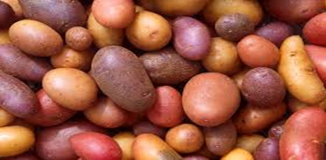

~~~~~~~~~~~~~~~~~~~~~~~~~~~~~~~~~~~~~~~~~~~~~~~~~~~~~~~~~~~~~~~~~~~~~~~~

Staple Foods: Sorghum

 Sorghum is also a drought-resistant crop. It is very important as a staple food in Africa, India, China, Southeast Asia, and Latin America. The United States is the major producer of sorghum, where it is used to feed animals, not people. Sorghum is often eaten as porridge or pounded into a flour to make bread. Other main producers of sorghum are India, Mexico, Argentina, China, Australia, and Ethiopia.

**Preparing foods made from Sorghum**~~~~~~~~~~~~~~~~~~~~~~~~~~~~~~~~~~~~~~~~~~

**Mixed Cereal Stew (Lesotho)**

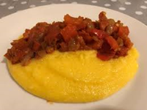*Ingredients:*

110 g wheat grains, soaked overnight—1/2 cup

110 g sorghum or millet, soaked overnight –1/2 cup

950 mL stock –4 cups

30 mL oil—2 tbsp.

1 onion, chopped—1

500 g mixture of potatoes, carrots and cabbage, chopped—2 cups

Milk

Salt and pepper

*Directions:*

1.      Start the stew by draining the cereals, keeping the water they were soaked in. now put into a pan with the stock, cover, and bring to a boil. Then turn down the heat and simmer for 45 minutes or until grains are soft, adding some of the retained soaking water if necessary, to prevent drying out

2.      Using another pan, heat up the oil and sauté the onion until it is golden. Add the potatoes and carrots and cook them for 10 minutes, stirring often so that they do not stick. Then put in the cabbage and the remaining soaking water and cook for 5-8 minutes

3.      When the vegetables are done, stir in the cooked cereals, add the milk and boil gently until the stew is the desired consistency. Then add the pepper and salt and serve with sliced tomatoes.

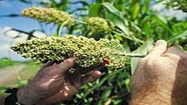

~~~~~~~~~~~~~~~~~~~~~~~~~~~~~~~~~~~~~~~~~~~~~~~~~~~~~~~~~~~~~~~~~~~~~~~~

**Other Staple Foods: Bananas, Cassava and Yams**

Other Staple Foods

The staple foods described in the previous pages are some of the main staples in the world today. However, there are other staples in use.

 + Bananas and plantain are grown and eaten as a staple food in tropical regions.

 + Cassava is a drought-resistant plant that is high in carbohydrates and low in protein, grown mainly as a subsistence crop.

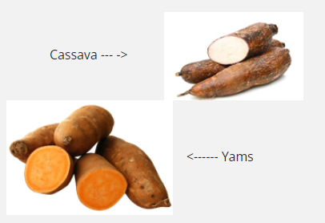 + Yams are an important staple in Nigeria, the Caribbean, parts of Latin America, and Southeast Asia.

Many countries are experiencing a similar shift away from traditional foods, but there is growing recognition of the importance of traditional food crops in nutrition. After years of being considered "poor people's foods" some of these crops are now enjoying a comeback. Cassava, considered a minor crop at the turn of the century, has now become one of the developing world's most important staples providing a basic diet for around 500 million people.

 All cultures have different foods that they eat at a majority of their meals, these foods are called staple foods. They are foods that can commonly be found in certain regions and are consumed by locals for many reasons like their abundance or ease of cultivation. Regions that are able to cultivate and get more foods, especially foods high in nutritional value and that can be used in many ways tend to have a competitive advantage and these countries are seen as superior as the advantage has helped propel them into first world status.

**Investigating My Plate**

 Question:

What have you eaten recently? Think about the foods that you have consumed over the last few days. Choose one specific meal (breakfast, lunch, dinner) that you have eaten over the last 2 days. Next, respond to the following inquiry questions:

1. What was the food you consumed? List the ingredients

2. What staple food was used for this dish? Name the food(s).

3. Research the staple food and identify **two** facts about the staple food that have not been mentioned throughout this lesson.