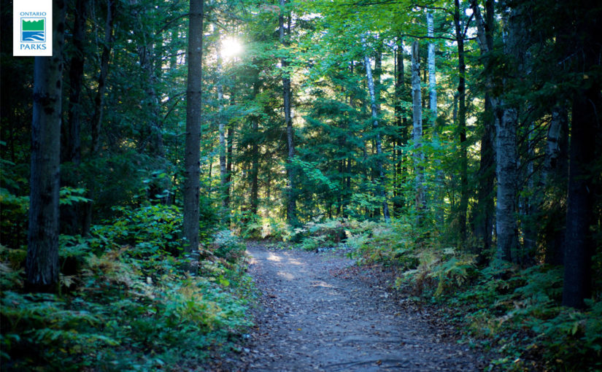

**THE ROAD NOT TAKEN**

**By Robert Frost**

Two roads diverged in a yellow wood,

And sorry I could not travel both

And be one traveler, long I stood

And looked down one as far as I could

To where it bent in the undergrowth;

Then took the other, as just as fair,

And having perhaps the better claim,

Because it was grassy and wanted wear;

Though as for that the passing there

Had worn them really about the same,

And both that morning equally lay

In leaves no step had trodden black.

Oh, I kept the first for another day!

Yet knowing how way leads on to way,

I doubted if I should ever come back.

I shall be telling this with a sigh

Somewhere ages and ages hence:

Two roads diverged in a wood, and I—

I took the one less travelled by,

And that has made all the difference.