Unit 1 Independent Study Period:
HFA4U: SAFE FOOD HANDLING

WEBCLASS (Assess. for Learning) Student: (10 marks)

May, 4, 2021

During this class you will have an opportunity to explore a number of websites to give you the tools and practice required to ensure that you will continue using safe food handling techniques… and if you don’t… what you need to know.

- Health Canada: Safe Food Handling

http://www.hc-sc.gc.ca/fn-an/securit/kitchen-cuisine/index-eng.php
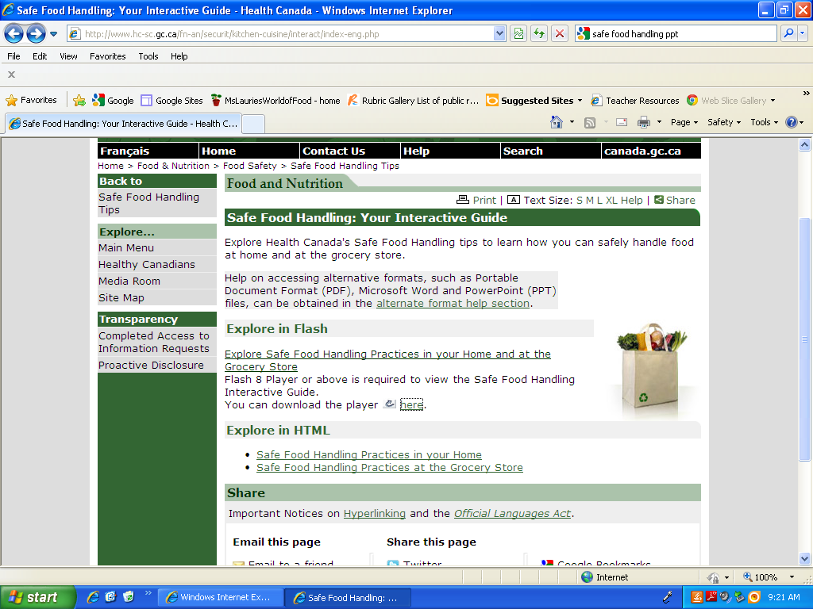
a) Check out the Safe Food Handling Tips so that you can answer questions like:

- What should pregnant woman, people over 60, and people with weak immune systems do differently?

- What is the name of the foodborne illness you get from eggs and how can you avoid it?

- How can you avoid getting sick from eating Fiddleheads?

- What is better?? Pasteurized Milk or Raw Milk?? Why??

b) Check out Produce Safety

- How can melons become contaminated?

- What is the best way to clean a mushroom?

- Should vegetables and fruits be soaked?

- Should vegetable and fruit cleansers or food wash products be used?

- Do bagged leafy greens have to be washed prior to eating?

- Should I feed my children sprouts?

- How do I know if the fruit juice product that I'm buying is pasteurized?

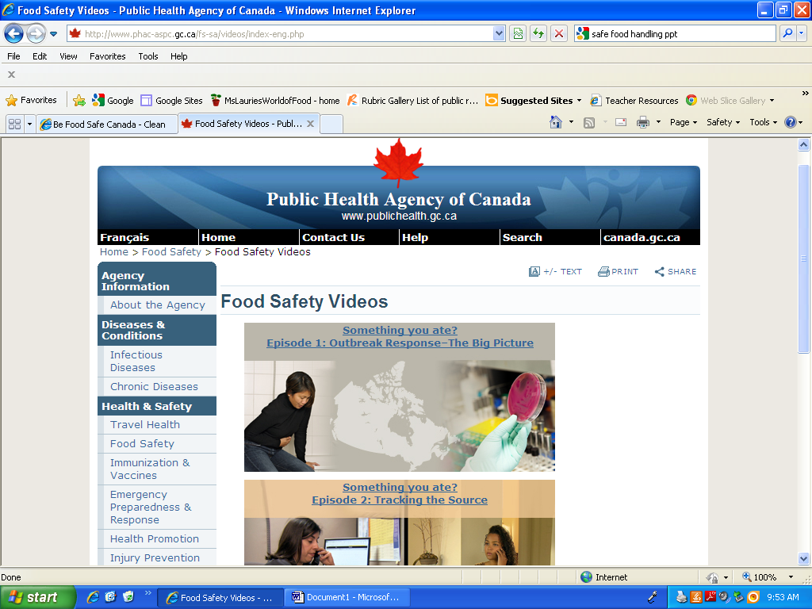
- Public Health Agency of Canada

Watch all 4 Episodes of Food Safety Videos to learn about Foodborne Illness Outbreak Illness response, Lab tracking and Lab Testing and protecting yourself.

http://www.phac-aspc.gc.ca/fs-sa/videos/index-eng.php

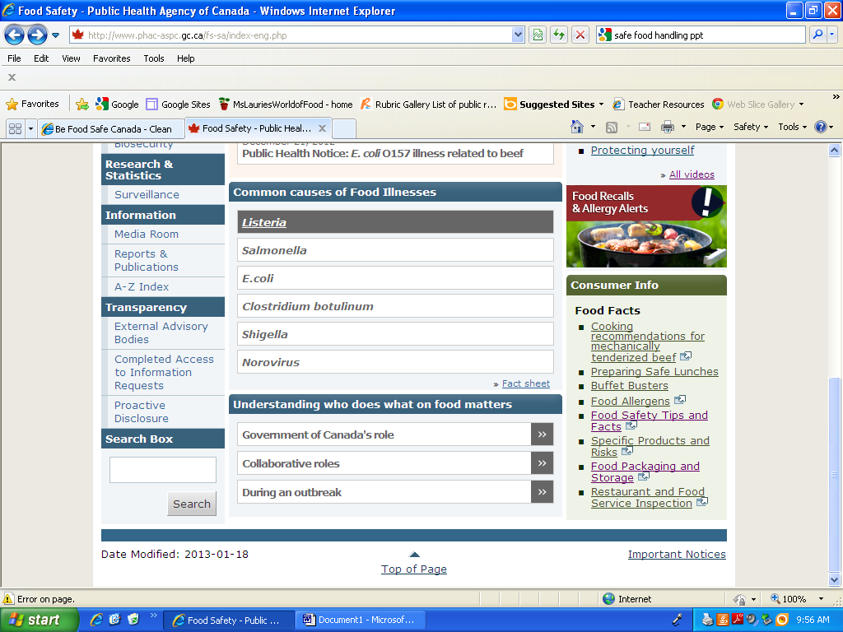
3. Public Health Agency of Canada

Complete the chart regarding specific foodborne illnesses.

http://www.phac-aspc.gc.ca/fs-sa/index-eng.php

