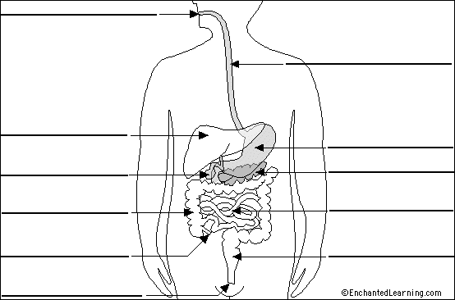
Meet Mr Phil!
A…………………….
B………………………
D………………………..
C………………………………….
F………………………….
E……………………………….
G…………………………….
H…………………………………
I……………………………..
J………………………………
K…………………………..
LEBEL DIFFERENT PARTS OF HUMAN DIGESTIVE SYSTEM INSIDE THE BOX A-K

