Unit3-Functional Foods (Assess. for Learning)
Student: Nov 22, 2022
Instructions:
- Most of the answers can be found in the Functional Foods power-point provided in today’s lesson & in the web-links in this worksheet. Some of the information in this worksheet & ‘Functional Foods’ power-point can be used for the next week’s assignment so do your best work & it will save you research time!

Functional Foods are _

Put a star next to the ones you eat regularly

  - Beans
  - Berries
  - Cruciferous vegetables
  - Chocolate
  - Citrus fruits
  - Pumpkin
  - Fish
  - Soy
  - Spinach
  - Sweet Potatoes
  - Tea
  - Tomatoes
  - Nuts
  - Whole grains
  - Yogurt

Key Terms

– a food that can help to promote health in humans

– chemicals found naturally in many plant products that act as antioxidants which prevent free radical damage in the body.

– water-soluble plant pigments (from colourful vegetables and fruit) that are beneficial to human health.

– natural chemicals found in foods that helps to prevent degradation due to free radicals (rebellious ions).

– the degree to which the human body can make use of a substance once it has been ingested.

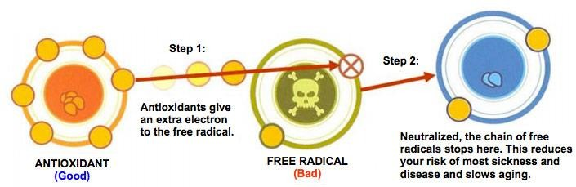

Watch video: https://www.youtube.com/watch?v=lG3OOXIXvxw

What is a free radical?

What creates free radicals in the body?

What is oxidative stress? And what can it cause?

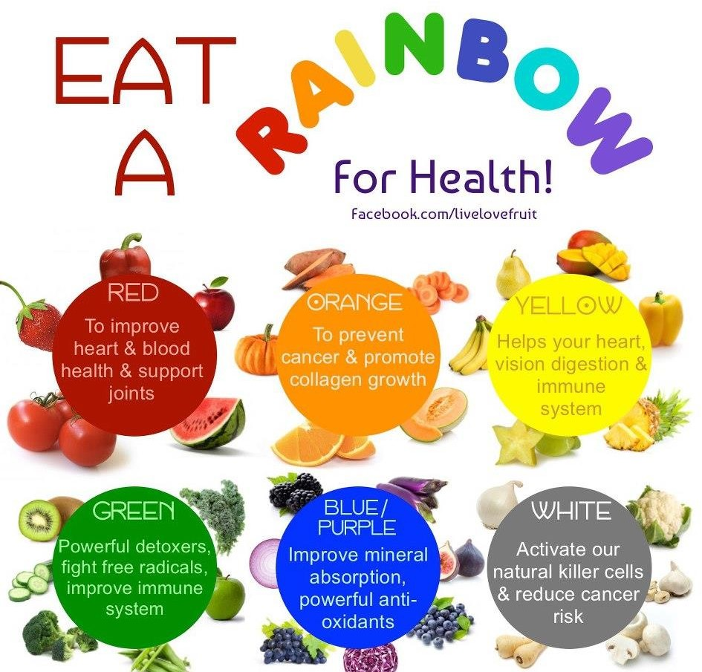
How do antioxidants work?

For each functional food dot jot a few key points (List two or three points about role of these functional foods in our body):

- Beans

- Berries
- Cruciferous vegetables
- Chocolate
- Oranges/Citrus

- Pumpkin

- Fish

- Soy

- Spinach

- Sweet Potatoes
- Tea

- Tomatoes

- Nuts

- Whole Grains

- Yogurt

