Gr. 12 Food and Nutrition and Health Exam Review

Type of Question
(You will fill this in together with your partner in class)

The Oral exam questions outline. This exam is worth 50 % of your final mark.

- What are the 4 ways to fight bacteria?

- What happens to bacteria at different temperatures?
- Safety/santitation rules.
- Which nutrients are macronutrients? Which out of these 4 provide you with energy?

- Which nutrients are considered micronutrients? What are the two types of vitamins? List the vitamins under each type.
- What are the two types of cholesterol? Where do you find it?
- What are the functions of carbohydrates, proteins, and fats? What are sources for all of these?
- Discuss complete, incomplete, and complimentary proteins.
- Discuss the digestion process from beginning to end. What happens at each part? What order are the macronutrients digested in? Be able to label a digestive system. What are the functions of each part?
- How is the 30% of fat distributed amongst the 3 types?

- Discuss function, source, toxicity, and deficiency symptoms of the vitamins and minerals
- What happens to one’s metabolic rate as you age?

- How are nutrients digested? Describe the digestion process from start to finish.

- Brainstorm three ways that food security can be achieved. Discuss food insecurity/food security.

- What are the factors that affect food choices? What are examples of each?

- Know various health concerns (e.g. osteoporosis)

- Be able to discuss the pros and cons of GM foods
- Discuss the infancy stage. What is special about this stage? What foods, at what age and what order should they be introduced?
- What nutrient(s) is/are most deficient in the average North American teen?
- List the types of vegetarians from most to least strict. What foods does each type of vegetarian eat? Why might someone become a vegetarian?

- What percentage of your daily dietary intake should go to carbohydrates, fats, and proteins?

- Choose 1 of the 6 regions and discuss the following: 2 countries in this region, 2 common staple foods, 2 customs/cuisines, and 2 factors affecting the foods available.

- Name the factors that influence food availability in different areas.

- Define: megadose, functional food, organic foods, subsistence farming, & food additives.

- Name and describe the 3 methods for determining a healthy weight?

- Calculate the BMI for the person below and discuss what risk group he/she would be in

- Be able to do the calculation questions (calories, grams of macronutrient, %s, comparison, and how they need to change.

- Be able to plan a meal for a family in which each member has a different need.

- Explain the “farm to table” process (think about local and global foods). What issues are related to importing/exporting foods?

- Why has their been a recent movement toward buying locally produced foods along with fair trade items? Think about all of the implications of local and global food production.

Learn how to analyze a Food label.

For example:
Analyzing Food Level: Learn more about Canadian Food label changes.
https://blog.astronovaproductid.com/2017/01/change-canadian-nutrition-facts/

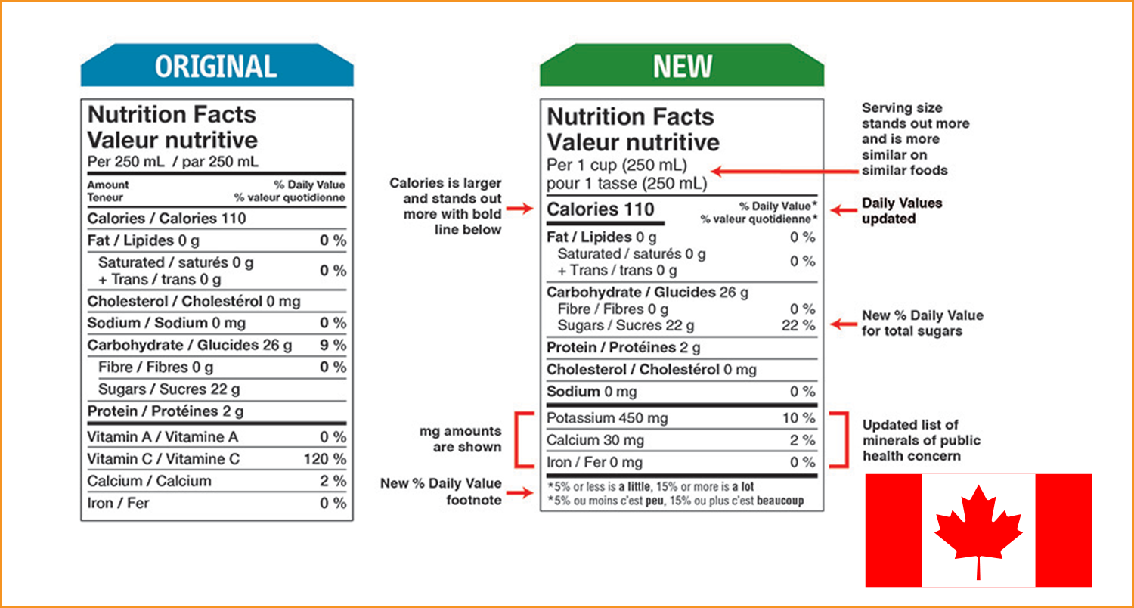

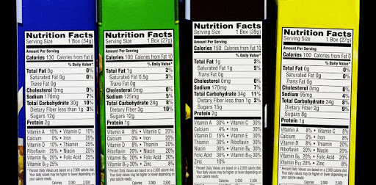

Learn how to analyze a BMI, risk associated to different BMIl and food recommendation for a different BMI ranges group of people (Male/Female/Children).

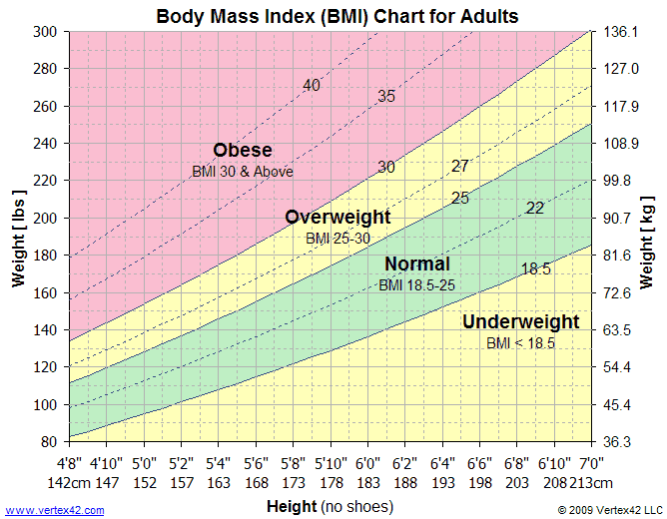

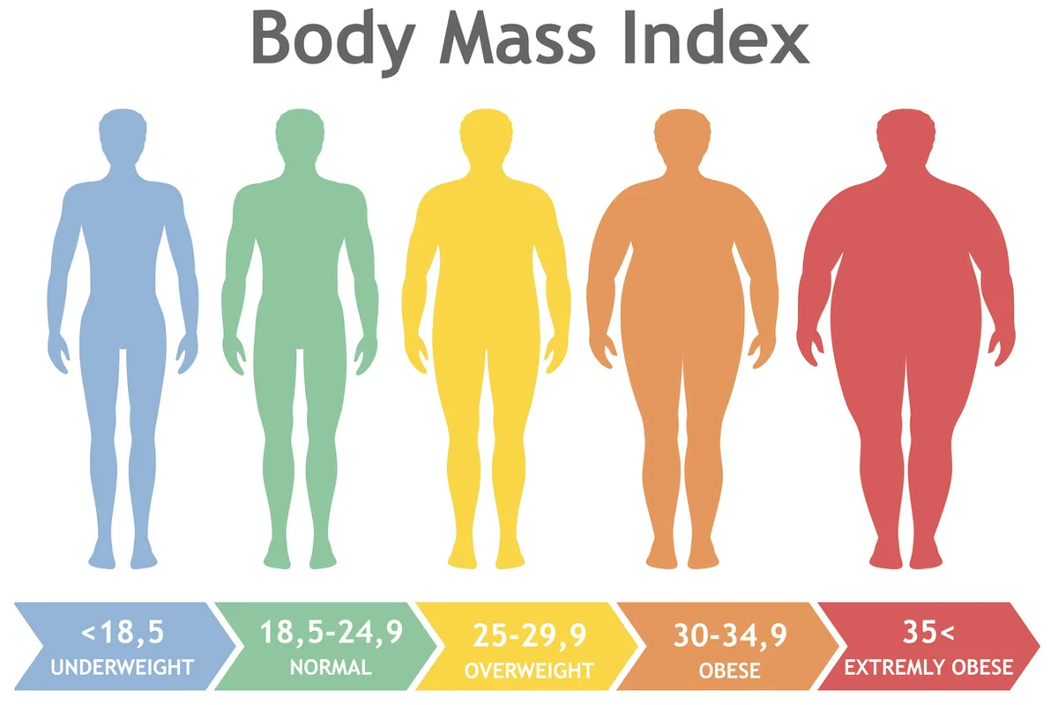
You can review: https://www.vertex42.com/ExcelTemplates/bmi-chart.html

