**SBI3U - Unit 4: Animals: Structure and Function**

**Assignment 6: Virtual Fetal Pig Dissection**

Student Name: Date Completed:

**PROCEDURE:** Go to the following website <https://www.whitman.edu/academics/majors-and-programs/biology/virtual-pig>

**Anatomical References** *- Click on “Anatomical References”*

1. Draw a sketch of a fetal pig below. Label the dorsal, ventral, and lateral surfaces.

*Click on “Regions of the Pig”, “Anterior/Posterior”, ”Medial/Lateral”, “Dorsal/Ventral” and “Proximal/Distal” to help you label the different areas.*

1. Explain the difference between anterior and posterior:
2. Explain the difference between dorsal and ventral:

**Sexing Your Pig** - *Click on “Sexing your pig”*

1. Explain how to externally tell a male and female fetal pigs apart:

**Digestive System**

*Click on “digestive system”. Go through the virtual dissection. While you are going through the virtual dissection , label the diagram of the internal anatomy and answer the question 5 and 6.*

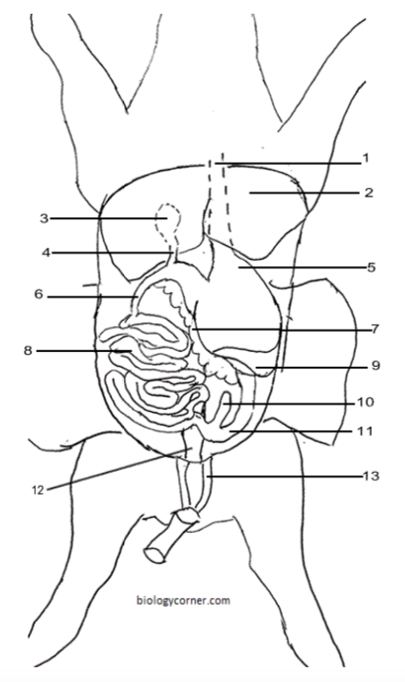

1. **The Head:** Write down what each organ is and what it does

Salivary Gland:

Pharynx:

1. **The Abdominal Cavity:** Write down what each organ is and what it does

Peritoneal Membrane:

Gall Bladder:

Pyloric Sphincter:

Pancreas:

Umbilical Arteries:

Mesentery:

**Circulatory System**

*Click on “circulatory system”. Go through the virtual dissection, answering the questions below as you do so.*

1. What is the circulatory system responsible for?
2. Using coloured pencils, colour in the different parts of the diagram using red (blood carrying oxygen) and blue (blood carrying carbon dioxide, little oxygen). Do not confuse the colour blue with what the colour of deoxygenated (low oxygen) blood is. It isn’t blue. It’s a very deep red.

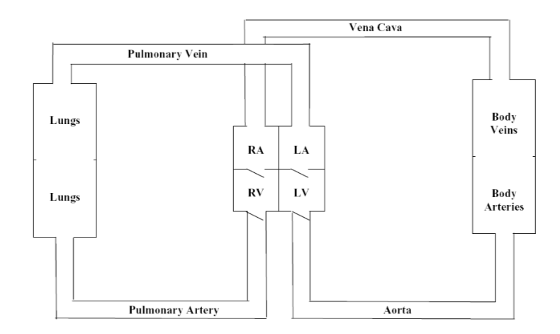

**Respiratory System**

*Click on “respiratory system”. Go through the virtual dissection, answering the questions below as you do so.*

1. What is the respiratory system?

**Reflection:**

What did you enjoy most about the virtual fetal pig dissection? What parts were surprising/unexpected? What was the most difficult part?