# Lesson 5: Review of Quadratic Functions (All Types)

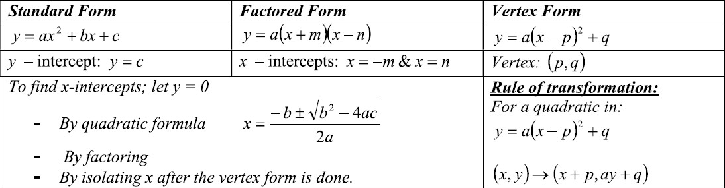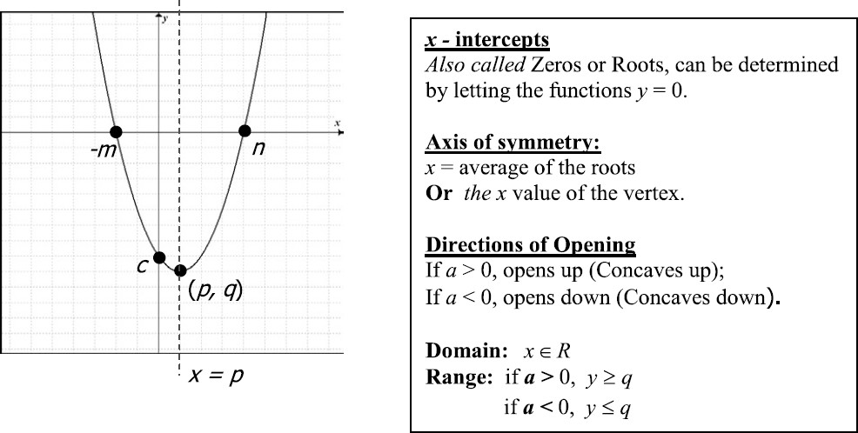

**Example 1:** Given the quadratic function 𝑓(𝑥) = −𝑥2 − 5𝑥 + 24

1. Determine the intercepts by factoring
2. Determine the axis of symmetry and the vertex.

**Example 2:** Given the Quadratic function 𝑓(𝑥) = 𝑥2 − 8𝑥 + 7

1. 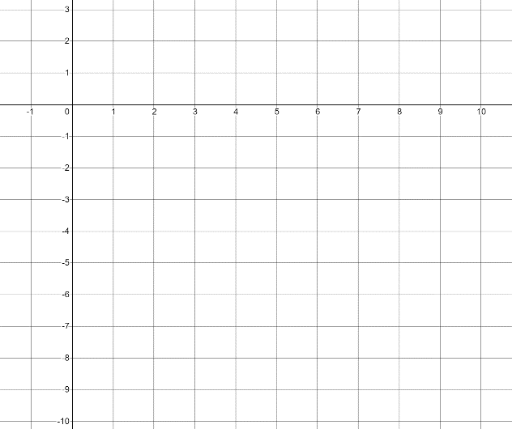Convert to vertex form, and sketch the graph
2. Determine the roots by isolating *x* from vertex form.
3. State the Domain and Range.

**Example 3:** Given the Quadratic Function 𝑓(𝑥) = 2𝑥2 + 5𝑥 − 1

1. 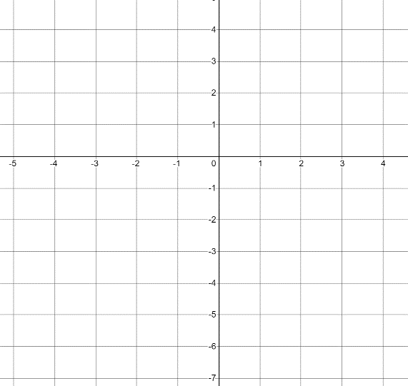Determine the roots by using the Quadratic Formula. Round your answer to 1 decimal place.
2. Determine the Vertex
3. Sketch the Parabola and determine the Domain and Range.

# Review Exercise

