Map of Canada (total marks 20)
Student:
Instructions
You are going to make TWO reference maps of Canada
• Make sure your map is neat and organized! Ensure that it is easy to read the location of the places.

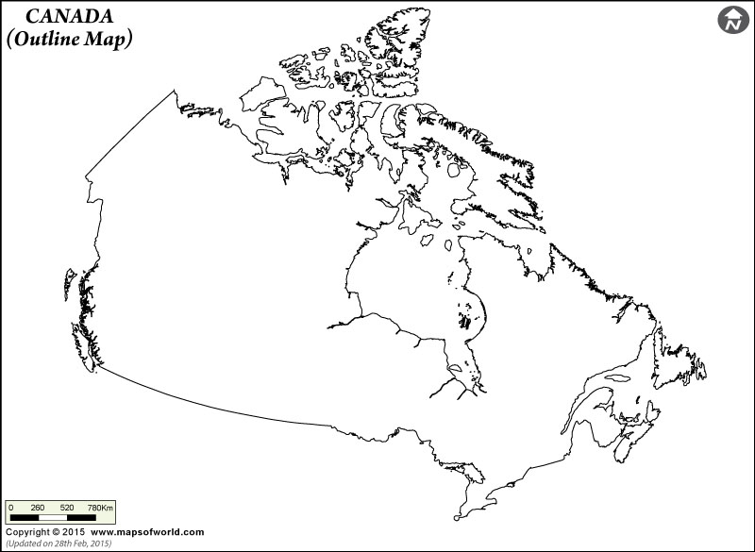

Required
Include the following ON BOTH MAPS: □ title □ north arrow □ label each province/territory and color it a different color (color is optional since class is online)
_____________________________________________________________________________________

Label the following on Map # 1
□ Provincial/territorial capitals (*each city must be in the right location)
□ National capital (*city must be in the right location)
□ Neighboring countries and land (United States of America and Greenland)
□ The major cities: (*each city must be in the right location) □ Vancouver □ Saint John □ Calgary
□ Saskatoon □ Winnipeg □ Ottawa □ Toronto □ Edmonton□ Montreal

____________

Label the following on Map # 2: □ The oceans, lakes and rivers: (*in blue)
□ Pacific Ocean □ Lake Ontario □ Atlantic Ocean □ Lake Michigan □ Arctic Ocean □ Lake Erie
□ Saskatchewan River □ Hudson Bay □ Lake Winnipeg □ Lake Manitoba □ Lake Superior □ Great Bear Lake □ Lake Huron

Part 2

1. Fill in the blanks: Latitude runs ------------------- Longitude runs----------------------
why latitude and longitude are important.?

2.. Label the following lines: Equator, Prime Meridian, Tropic of Cancer, Tropic of Capricorn, Arctic Circle, Antarctic Circle. 3. Label the four hemispheres on the world map provided.

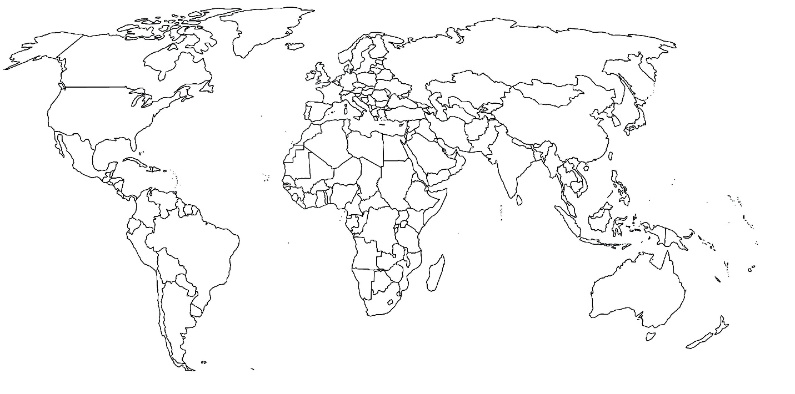

 | LEVEL 1 | LEVEL 2 | LEVEL 3 | LEVEL 4
Knowledge | Provinces, territories and cities are labelled incorrectly. | Some provinces, territories and cities are labelled covertly | Most of the provinces, territories and cities are labelled covertly | Each province, territory and cities are labelled covertly
communication | Spelling and capitalization are incorrect | Spelling and capitalization are mostly correct | Spelling and capitalization are correct | Spelling and capitalization are all correct
Application | Words are illegible | Some words are difficult to read | Map is neat, words are not crammed together | Map is very neat; words are not crammed together
Thinking | Does not use geographic inquiry process and the concepts of geographic thinking. | Use geographic inquiry process and the concepts of geographic thinking with limitation | Use geographic inquiry process and the concepts of geographic thinking. | Use geographic inquiry process and the concepts of geographic thinking effectively

Overall Expectations
A1. Geographic Inquiry: use the geographic inquiry process and the concepts of geographic thinking when investigating issues relating to Canadian geography
A2. Developing Transferable Skills: apply in everyday contexts skills, including spatial technology skills, developed through the investigation of Canadian geography, and identify some careers in which a background in geography might be an asset

