Interpreting a Topographic Map
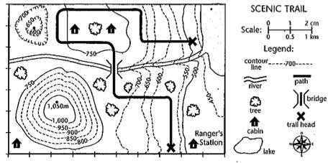
Imagine you are taking a hike through a national park. The park ranger gives you a topographic map to help you find your way. Use the map below to answer the following questions.

- At what end of the park is the ranger’s station?
  - northwest b. southwest
c. southeast d. northeast

- At what elevation is the ranger’s station?

- At what elevation is the bridge?

- How many cabins are at or above an elevation of 750 m?

- What land feature is in the southwest corner of the park?

- How high is the highest point in the park?

- What is the contour interval of this map?
8. What is the lowest point near the lake?
9. 2 cm scale indicate how much Km?
10 Let’s say that the trail starting from Rangers station to the lake is about10 cm on the map, how long will be the actual trail in km?

