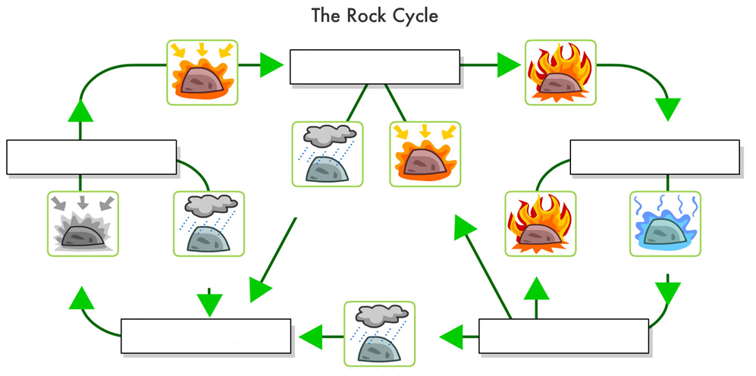
CGC1D-Unit 2-Physical Geography Student: 9/11/2020

