Creating and Analyzing Population Pyramids
Unit 4: Changing Populations
CGC1W

Student: Date:
Teacher: Mr. Victor Gajardo-Aburto Course: Exploring Canadian Geography

INSTRUCTIONS:
- Create two population pyramids: 1) Create your own population pyramid for Canada using information from a trustable source on the Internet. 2) Create one pyramid for a developing country (Bangladesh, India, Bulgaria or Mexico) for comparison. Your pyramids should include: a title, year, and appropriate colours.
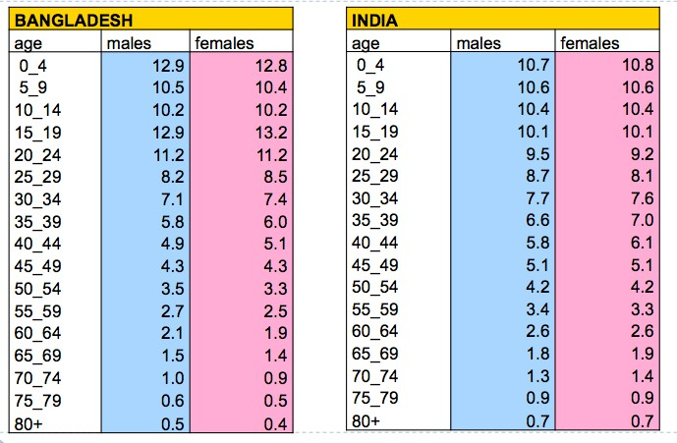
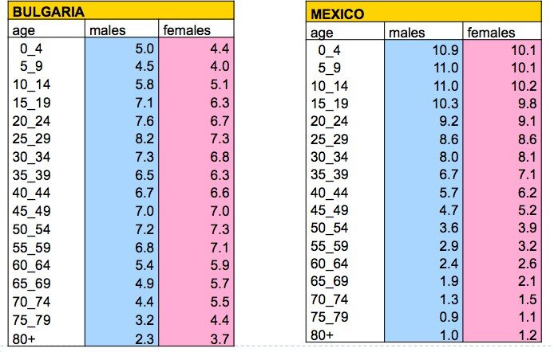

- What type of population pyramid is each one? Explain.

- Complete the following analysis questions once your population pyramid of Canada is complete on page 3.
  - Describe the shape of the Canadian population pyramid. What type of pyramid is it?
  - How many males are there in your age cohort? Females?
  - How do the pyramids compare? What might explain the similarities or differences that you notice?
  - Predict what Canada’s population pyramid will look like in 2050. Draw a small sketch to show what shape you think it will take on in the future and provide an explanation for the shape you have drawn.

