WORDS ARE BIRDS by FRANCISCO X. ALARCÓN
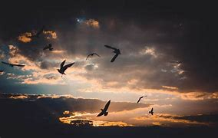
words
are birds
that arrive
with books
and spring

they
love
clouds
the wind
and trees

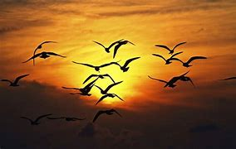
some words
are messengers
that come
from far away
from distant lands

for them
there are
no borders
only stars
moon and sun

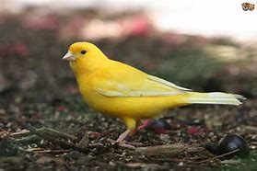

some words
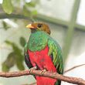
are familiar
like canaries
others are exotic
like the quetzal bird


some can stand
the cold
others migrate
with the sun to the south

some words
die
caged—
they're difficult
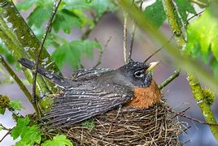
to translate

and others
build nests
have chicks
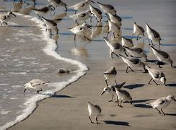
warm them
feed them
teach them
how to fly

and one day
they go away
in flocks

the letters
on this page
are the prints
they leave
by the sea

