CHC2D Unit 1Test Teacher: Mr. Bergman Student: 11/6/20
Part A: (Knowledge & Understanding (WWI-key terms/Vocabulary)
Part a (____/25 TOTAL MARKS)
Multiple Choice Questions: Circle the letter of the most correct response. ( /15 marks)
1. His assassination in June 1914 touched off a series of events, which led to WWI.
A. Gavrilo Princip
B. John F Kennedy
C. Kaiser William
D. Archduke Ferdinand
2. Which of the following statements illustrates the view of those Canadians who wished to maintain strong ties to Britain during WW I?
A. We believe we should build the French Canadian nation
B. This is a European war. Canada should have no part in it.
C. When Britain goes to war, Canada goes to war too.
D. Pacifists need not participate even when casualty rates are high
3. In 1915 at Ypres, Germany unleashed
A. a new form of tank.
B. aircraft used as bombers.
C. a terrible chlorine gas attack.
D. a horrific new long–range artillery piece.
4. Rats, mud, and shell shock are all associated with ______?
A. over the top
B. unrestricted submarine warfare
C. armistice
D. trench warfare
5. The Ross rifle, made in Canada for the Canadian soldiers, proved
A. that Canadians knew how to make great rifles.
B. to be such a success that the British forces started using them.
C. to be a terrible rifle for the battlefield and was soon discarded.
D. to be a light, efficient, and reliable weapon.
6. When the war ended, _______________ was chosen as the site of the Canadian War Memorial in France; it was here on Easter Monday in April 1917 that Canadians won its most celebrated battle.
A. Hill 70
B. Vimy Ridge
C. Normandy
D. Flanders Fields
7. Billy Bishop was a:
A) -Canadian ace pilot in the war
b) -member of the opposition party
c) -Russian ace pilot in the war
d) - minister of the militia at the beginning of the war
8. During the First World War, women worked in factories because
a) - there were not enough men to fill the jobs
b) -women were able to do the skilled jobs as well as men
c) - women wanted to help in the war effort
d) -all of the above
9. The disastrous explosion in Halifax harbour in 1917 was caused by
A. enemy rockets launch from submarines in the harbour.
B. bombs set off by German spies in the city.
C. the collision of two munitions ships.
D. returning aircraft missing the airport and crashing into the city.
10. The Prime Minister of Canada during the tense World War One years was
a) Sir Wilfred Laurier
b) Sir Robert Borden
c) Sir John A MacDonald
d) Mackenzie King
11. Which group opposed conscription?
A. Farmers
B. Pacifists
C. French Canadians
D. All of the above
12. The First World War cost Canada approximately $ 1 000 000 / day. To help the war effort, the people of Canada;
a) - allowed women the right to vote
b) -bought Victory Bonds
c) - voted for a reciprocity deal with the United States
d) -hoarded sugar, salt and flour in their homes
13. Mothers, sisters, and wives of men serving in the Canadian armed forces were given the right to ________ in September of 1917
A) -work on the home-front
b) - extra allowances
c) -vote
d) -none of the above

14. An armistice is
A. -the surrender of one side in a battle to the other.
B. -an agreement to stop all hostilities by both sides in a war.
C. -a type of surgery developed to reconstruct soldiers’ injured limbs.
D. - a French term for the lull between battles.
15 The Treaty of Versailles
A. - clearly established Germany as being solely responsible for the Great War.
B. - established Russia as a major player on the world stage.
C. -ensured that the United States would never again go to a war in Europe.
D. -was signed by every nation that participated in the First World War.
Section 2: Short Answers: ( /10 marks)
What were the 4 MAIN causes of WWI: (list them)
( /4 marks)

What was it like to live in the trenches during WWI?

( /2 marks)

What was the historic significance (importance) of the Battles of Vimy Ridge, & the 100 day War?

( /4 marks)
Part B Thinking & Inquiry Questions: Short & Long Answers: ( /25 TOTAL MARKS)
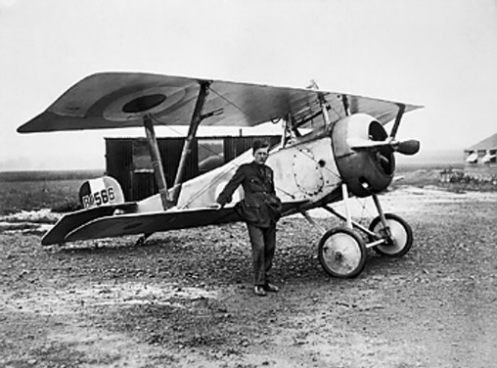
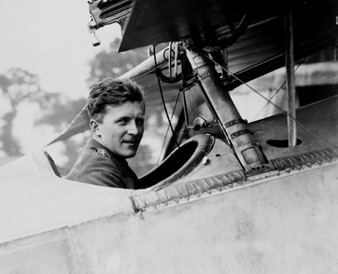
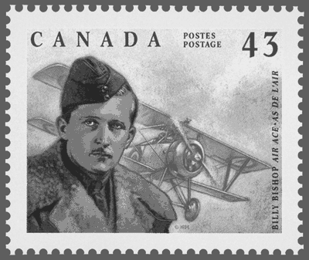
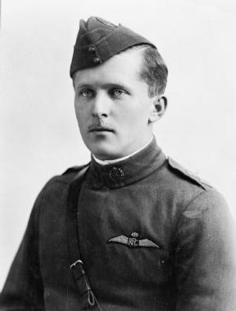
Why do we recognize some people as heroes but not others?
Thinking Question 1. Considering the Heroes of World War I
Remember that “good evidence” is; specific, accurate, relevant, and detailed. Try to balance the evidence you record on both sides of the chart.
Evidence of Billy Bishop’s Heroism | Evidence of Billy Bishop’s “not-so” Heroism
( /20 marks)

2. Why do you think many Canadians have recognized Billy Bishop more than Francis Pegahmagabow as a war hero, even though Francis Pegahmagabow killed more people as a sniper?( -Use 5 reasons & 5 sentences to explain your answer.) ( /5 marks)

Part C- Communication Questions ( /25 marks)
- How did the United States influence & change Canadian culture? (-explain the 4 ways it changed Canadian culture in 3-4 sentences)

( /4 marks)
2. How did the U.S. change the forest industry in many places in Canada?

( /2 marks)
3. How did the U.S. change the mining & auto industry in Canada?

( /4 marks)
4. How did technology in the 1920’s change life in the cities for many Canadians? (-write down 4 different ways)

( /4 marks)
5. How did the war technology make life easier to travel for many Canadians; especially richer Canadians living in the cities?
(-explain 4 ways it helped Canadians) ( /4 marks)

6.) How were Asian immigrants treated after WW1? ( /2 marks)

7. Explain the differences between primary and secondary industries? ( /2 marks)

- What happened to women in 1929 & why was that important to them? ( /3 marks)

Part D: Application Questions: ( /25 Marks)
1.a)If you were living during WW 1 explain in a few sentences what you would be doing if you were 18 years old? How would you survive as a young man or woman? Remember, you are an ordinary Canadian man or woman who does not come from a rich family. (-give at least 4-
b) 5 reasons for your long paragraph answer & double-space all your sentences) ( /20 marks)

2. How did general strikes across Canada affect many thousands of workers in Canadian cities after WWI? ( /5 marks)

