Reading Control 3: Pierre Trudeau
Unit 3: Canada 1945 – 1982
CHC2D

Student: Date:
Teacher: Mr. Victor Gajardo Course: Canadian History since World War I
Score: Grade:

INSTRUCTIONS
I. Read the text about Pierre Trudeau.
II. After reading the text, answer the questions on page 3. Read the text again if necessary.

Pierre Elliott Trudeau

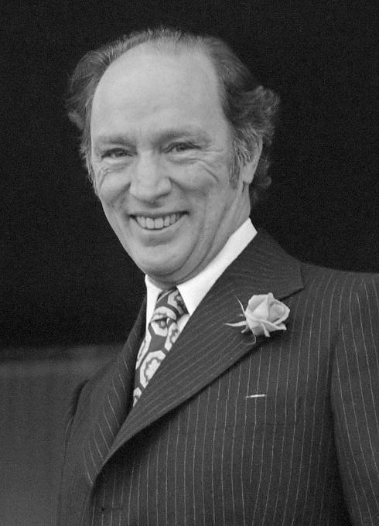
Pierre Elliott Trudeau, prime minister of Canada 1968–79 and 1980–84, politician, writer, constitutional lawyer (born 18 October 1919 in Montreal, QC; died 28 September 2000 in Montreal). A charismatic and controversial figure, Pierre Trudeau was arguably Canada’s best-known politician, both at home and abroad. He introduced legal reforms to make Canada a more “just society” and made Canada officially bilingual with the Official Languages Act of 1969. He negotiated Canada’s constitutional independence from Britain and established a new Canadian Constitution with a Charter of Rights and Freedoms. He played an important role in defeating the Quebec separatist movement of the 1970s and 1980s; although his decision to invoke the War Measures Act in response to the 1970 October Crisis drew sharp criticism. His federalist stance as well as his language and economic policies alienated many in Canada, particularly in the West. His eldest son, Justin Trudeau, became leader of the Liberal Party in 2013 and prime minister in 2015.

Trudeau and Federalism
After the Liberal victory in the 1960 provincial election, the Quiet Revolution fulfilled some of Trudeau’s hopes for change. At the same time, it revealed a deep rift between Trudeau and many of his former colleagues who were moving toward the idea of an independent Quebec. As a law professor at Université de Montréal in the 1960s, Trudeau became a sharp critic of contemporary Quebec nationalism. He argued for a Canadian federalism in which English and French Canada would find a new equality.

Entry into Federal Politics
Pierre Trudeau joined the federal Liberal Party in 1965. He was recruited along with union leader Jean Marchand and journalist Gérard Pelletier. Trudeau was elected to Parliament in the riding of Mount Royal. He was later appointed parliamentary secretary to Prime Minister Lester Pearson.

A rising star in the Liberal Party, Trudeau was named minister of justice in 1967. In this role, he gained national attention for reforming divorce law; as well as for amending the Criminal Code to liberalize laws on abortion, homosexuality, and public lotteries. He also established a reputation as a defender of a strong federal government against the nationalist demands of Quebec.
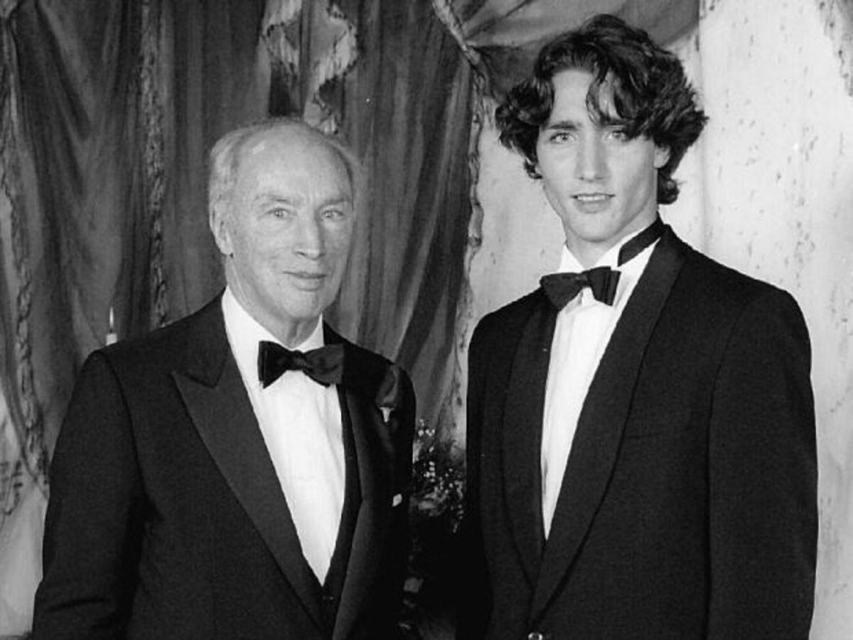
As justice minister in 1967, Trudeau introduced reforms to the Criminal Code that effectively decriminalized homosexuality. Trudeau’s stated explanation for doing so — that “there is no place for the state in the bedrooms of the nation” — captured the zeitgeist of a new, more progressive era. The same sentiment runs through the creation of the Charter of Rights and Freedoms (1982) and the legalization of same-sex marriage (2005). The phrase marked Trudeau as edgy, iconoclastic and refreshingly sophisticated. It also helped launch him to political superstardom, signaling a sharp generational shift in Canada’s political leadership.

Trudeaumania
Trudeau was persuaded to contest the Liberal leadership in 1968. He was elected on the fourth ballot. After winning the general election on 25 June 1968 In the ensuing general election — which was dominated by “Trudeaumania” — his government won in a landslide with 153 (of 249) seats and 45.37 per cent of the popular vote. On 20 April 1968, he was sworn in as Canada’s 15th prime minister. He then began a period in office which was to last longer than that of any other prime minister, except William Lyon Mackenzie King and Sir John A. Macdonald.

The October Crisis
The most dramatic event of Trudeau’s first government was the October Crisis of 1970. British diplomat James Cross and Quebec cabinet minister Pierre Laporte were kidnapped by the Front de Libération du Québec (FLQ), a militant Quebec independence movement. In response, Trudeau invoked the War Measures Act; this gave the government sweeping powers of arrest, detention and censorship. Shortly after, Laporte was murdered by his abductors. Controversy over the appropriateness of these measures and their effect on liberal democracy in Canada and Quebec has continued to the present.

- List two reasons why Pierre Trudeau is considered one of Canada’s best-known politicians. (Knowledge, 4 pts.)
  - Reason 1:
  - Reason 2:

- For how many years was Pierre Trudeau Prime Minister of Canada? (Knowledge, 4 pts.)

- In your opinion, which event or decision from Trudeau’s political career is the most important? Why? Explain your answer. (Thinking, 8 pts.)

- In 1967, as Justice Minister, Trudeau decriminalized homosexuality. What is the impact of this decision in the future of Canada? Use between 3 and 7 sentences to describe your answer. (Communication, 8 pts.)

- Is there a relation between the Independence of Quebec and the October Crisis? Explain your answer. (Application, 8 pts.)

Rubric Reading Control 3
Unit 3: Canada from 1945 to 1982

Criteria / Question | Level 1  4 pts. | Level 2  5 pts. | Level 3  6 - 7 pts. | Level 4  8 pts.
Question 3.  Analysis of the event and its consequences; formulated clearly. Analytical/critical response to the event.  (Thinking/Inquiry) | Uses critical thinking  processes with  limited  effectiveness. | Uses critical thinking  processes with  some  effectiveness. | Uses critical thinking  processes with  considerable  effectiveness. | Uses critical thinking  processes with a high degree of  effectiveness.
Question 4.  Communicating Ideas: format, grammar, spelling, and clarity of thought. Sentence structure  (Communication) | Expresses and  organizes ideas  and information  with limited  effectiveness. Uses more or less than the sentences required. More than six grammatical or spelling mistakes. | Expresses and  organizes ideas  and information  with some  effectiveness. Uses more or less than the sentences required. Four or five grammatical or spelling mistakes. | Expresses and  organizes ideas  and information  with considerable  effectiveness. Writes the sentences required. Two or three grammatical or spelling mistakes. | Expresses and  organizes ideas  and information  with a high degree  of effectiveness. Writes the sentences required. One or no grammatical or spelling mistakes.
Question 5.  Making connections within  and between various  contexts  (Application) | Makes  connections  between the Independence of Quebec and the October Crisis with  limited  effectiveness. | Makes  connections  between the Independence of Quebec and the October Crisis with  some  effectiveness. | Makes  connections  between the Independence of Quebec and the October Crisis  with  considerable  effectiveness. | Makes  connections  between the Independence of Quebec and the October Crisis  with a  high degree of  effectiveness.

