WRITING: AN OPINION ESSAY I
Unit 4: Canada in 1982 - Present
LEARNING GOAL: at the end of this lesson, you will be able to write an opinion essay

1. Warmer, speaking. Answer these questions:
- In your opinion, what makes a healthy lifestyle?
- Do you have a healthy lifestyle? Why? / Why not?

2. Identifying. Read the task below. What are the two elements that the task contains? Highlight or underline them using different colours.

Many people agree that teenagers don’t get enough exercise. Write an essay in which you give your own view of the problem and propose ways of solving it.

3. Applying. Read the essay below. Find and highlight the writer’s opinion about the problem. Then, underline the two solutions they propose.

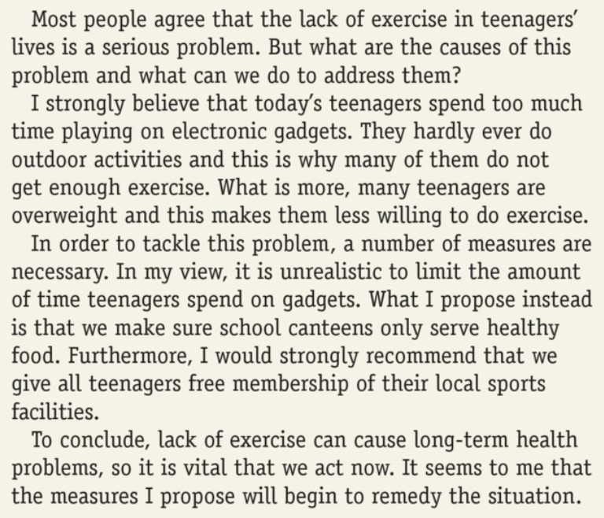

4. Applying. Read the Writing Strategy below. Read the essay again and answer the questions.
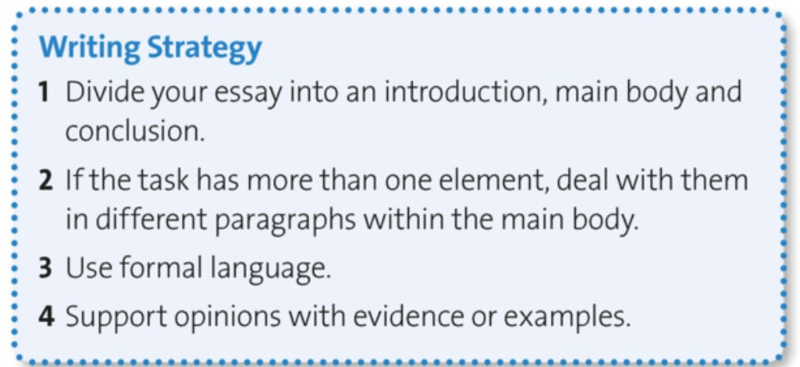

- Which paragraph(s) correspond to:
  - the introduction? .
  - the main body? and .
  - the conclusion? .
- Which paragraph(s) deals with:
  - the causes? .
  - suggests solutions? .
- Write three examples of formal language used in the essay:
  - .
  - .
  - .

5. Identifying, applying. Complete the phrases with the words below.
agree - conclusion - propose - said - seems - solution - sum - view - What

1. INTRODUCING YOUR OPINIONS | I (strongly) believe that…  It to me that… | In my ,  As I see it,
2. INTRODUCING OTHER PEOPLE’S OPINIONS | It is often that…  It is a common belief that…  Most people that…
3. MAKING AN ADDITIONAL POINT | is more…  Not only that, but… | Moreover,  Furthermore,
4. INTRODUCING PROPOSALS AND SOLUTIONS | One might be to…  I would (strongly) recommend that…  What I (instead) is that…  It is said that…  In order to tackle this problem, I suggest that…
5. CONCLUDING | To up,  In , | To conclude,

6. EXIT TICKET. Complete the exit card on Moodle.

SELF-EVALUATION

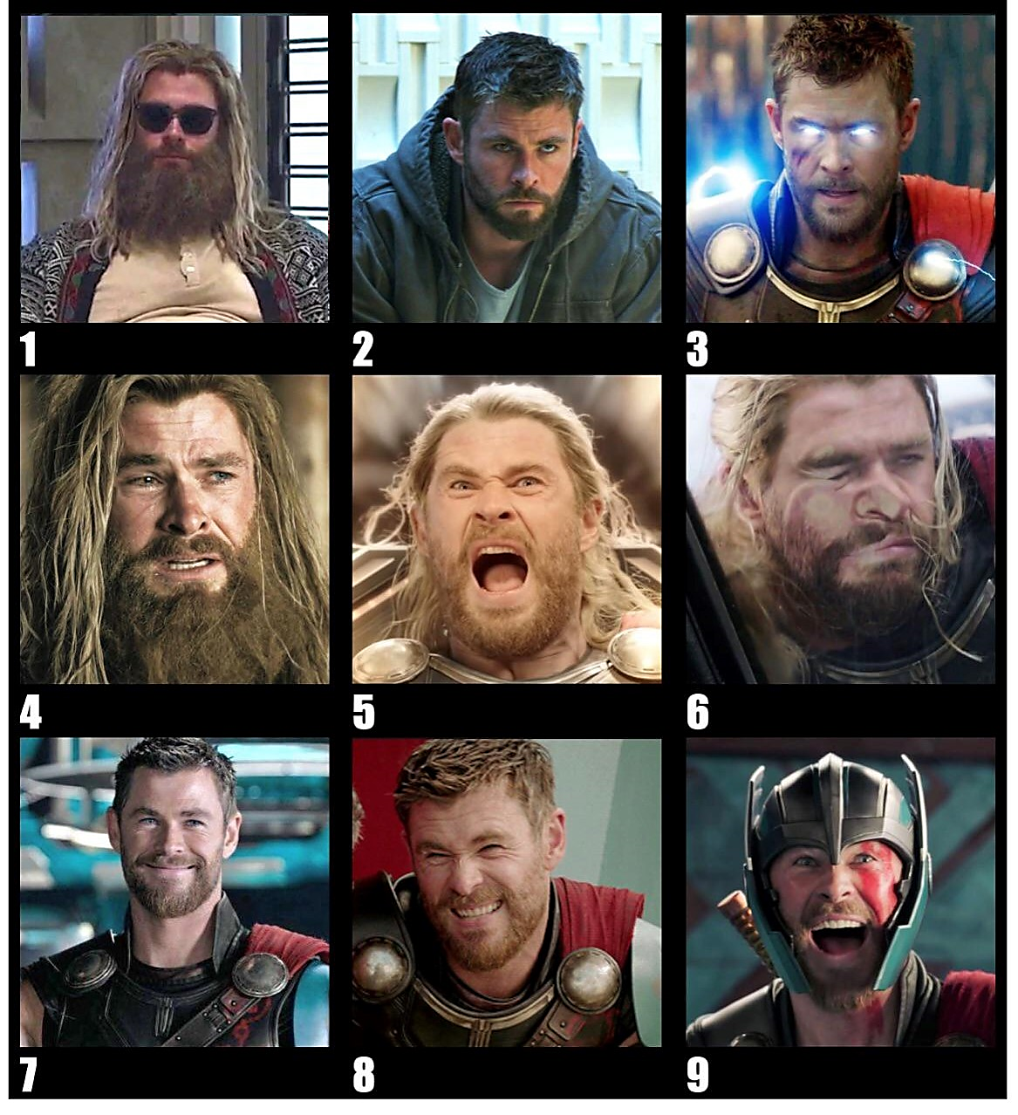
Finally, on a scale of Thor, how do you feel after this lesson? Number ___.

