File: ESLDO_CharacterMap_20260326.docx, or.pdf

Appendix - A4 - Character Map
Date Created: Friday, March 6th, 2026
Date Modified: Monday, March 9th, 2026

Definition:
Character Map - is a visual organizer that helps readers understand a character more deeply by breaking down key information about them.
What it usually includes
- Name and role in the story
- Physical traits (appearance)
- Personality traits (what they’re like)
- Actions (what they do)
- Motivations (why they do it)
- Relationships with other characters
- Changes from the beginning to the end
Moodle example: Main Character: Mieko

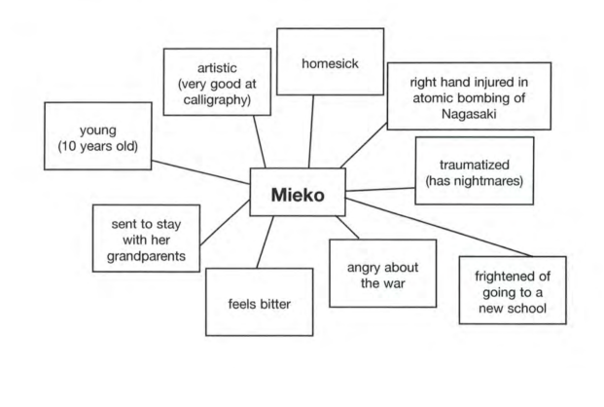

ChatGPT template generated on: Monday, March 9th, 2026
✏️ ELL‑Friendly Character Map Template (Simplified)
Character Name:
Who is this character? (job, role, family)
What do they look like?
What are they like? (personality words)

What do they want?

What problems do they face?

How do they change?

ChatGPT Generated on: Friday, March 6, 2026
Character Map — Fill‑in‑the‑Blank Template
Name & Role
Character’s Name: ______________________________
Role in the Story: _______________________________
Physical Traits (What the character looks like)
_______________________________________________________________________
_______________________________________________________________________
_______________________________________________________________________
Personality Traits (What the character is like)
_______________________________________________________________________
_______________________________________________________________________
_______________________________________________________________________
Important Actions (What the character does)
_______________________________________________________________________
_______________________________________________________________________
_______________________________________________________________________
Motivations (Why the character acts this way)
_______________________________________________________________________
_______________________________________________________________________
_______________________________________________________________________
Relationships (Who the character interacts with)
_______________________________________________________________________
_______________________________________________________________________
_______________________________________________________________________

How the Character Changes (Beginning → End)
At the beginning: _____________________________________________
At the end: _________________________________________________
What changed: _______________________________________________

