LEARNING GOALS
By the end of today’s lesson I will be able to:
- Understand what a system of equations is
- Understand the three possible types of solutions to a Linear/Quadratic System
- Solve for and find the solutions to a Linear/Quadratic System

Thinking back to Grade 9 math, we learned about __________ of linear equations. We were considering ______ or more lines at the same time.

We could have ________ Solution, ________ Solutions or ______ Solutions

Now we are going to consider Linear/Quadratic systems. This means we will be looking at the graph of a _______________ and of a ____________ at the __________ ___________.

There are ______ possible types of solutions to a Linear/Quadratic system :

1) 2) 3)
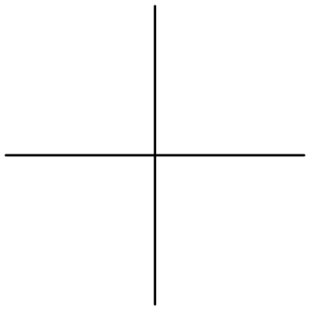

EXAMPLE 1
- Quadratic Equation $y=2x^{2}+7x-4$

- Linear Equation $x+y+12=0$

Finding the parabola’s vertex: 4 [K] Finding x- and y- intercepts of the line: 2 [K]

Find the parabola’s x-intercepts: 3 [K] Finding point(s) o f intersection (if any) of the
Quadratic and linear functions: 5 [K]

Analysis of Parabola 8 [K]
Direction of Opening _____________
y-intercept ______________
MAX MIN value of y is ______________
And occurs when x is ______________
Domain: ______________
Range: ______________
Equation of the axis
of symmetry ______________

Draw a large sketch of the parabola and the line on the graph below. Label the vertex of the parabola, ALL intercepts and any point(s) of intersection. 7 [A] 3[C]

EXAMPLE 2
- Quadratic Equation $y=-2x^{2}-4x+6$

- Linear Equation $3x-y+2=0$

Finding the parabola’s vertex: 4 [K] Finding x- and y- intercepts of the line: 2 [K]

Find the parabola’s x-intercepts: 3 [K] Finding point(s) o f intersection (if any) of the
Quadratic and linear functions: 5 [K]

Analysis of Parabola 8 [K]
Direction of Opening _____________
y-intercept ______________
MAX MIN value of y is ______________
And occurs when x is ______________
Domain: ______________
Range: ______________
Equation of the axis
of symmetry ______________

Draw a large sketch of the parabola and the line on the graph below. Label the vertex of the parabola, ALL intercepts and any point(s) of intersection. 7 [A] 3[C]

HW p.198 4ac, 7 REVIEW MATERIAL ON P.202, 204

