Lesson 5: Review of Quadratic Functions (All Types)
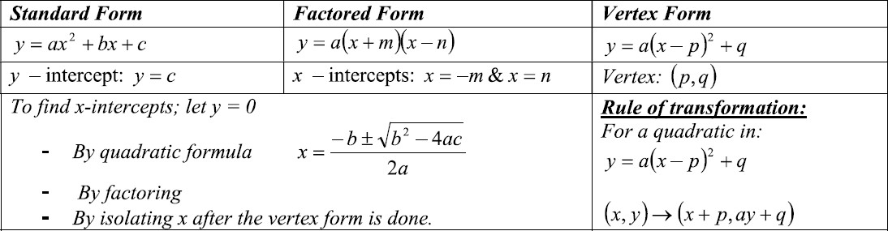
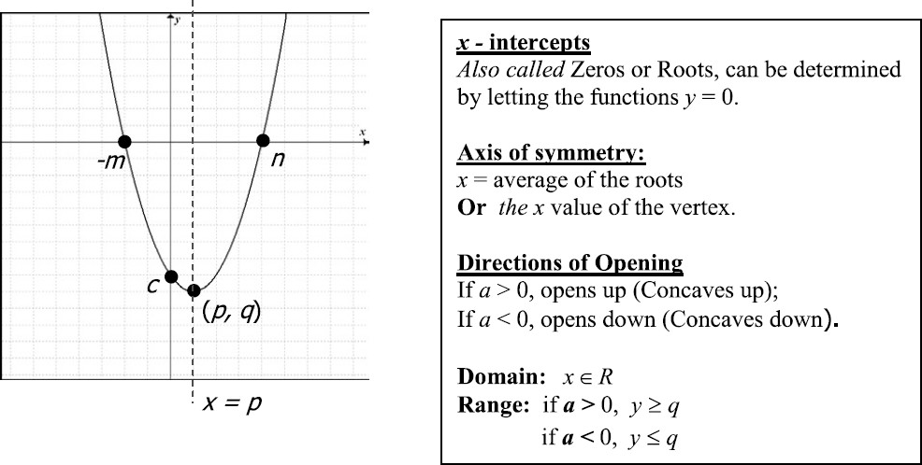

Example 1: Given the quadratic function 𝑓(𝑥) = −𝑥² − 5𝑥 + 24
- Determine the intercepts by factoring
- Determine the axis of symmetry and the vertex.

Example 2: Given the Quadratic function 𝑓(𝑥) = 𝑥² − 8𝑥 + 7
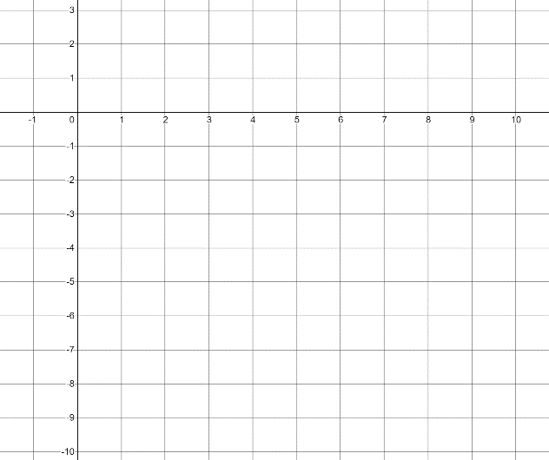
- Convert to vertex form, and sketch the graph
- Determine the roots by isolating x from vertex form.
- State the Domain and Range.

Example 3: Given the Quadratic Function 𝑓(𝑥) = 2𝑥² + 5𝑥 − 1
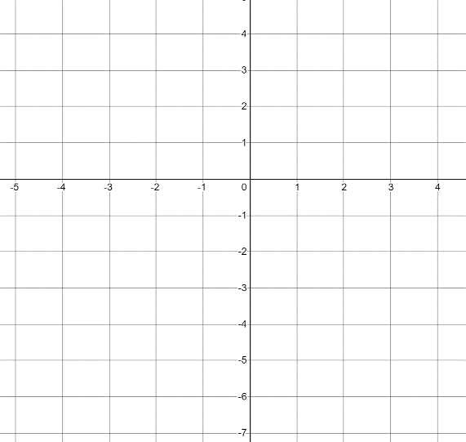
- Determine the roots by using the Quadratic Formula. Round your answer to 1 decimal place.
- Determine the Vertex
- Sketch the Parabola and determine the Domain and Range.

Review Exercise
