Grade 11 SBI3U Midterm Exam

COURSE NAME: Biology

Teacher: Caleb Espinosa

Time: 2 hours
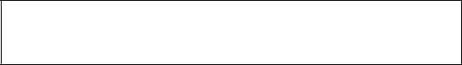

Pages: 4

Student’s Name:

Date: Sept 27th, 2027
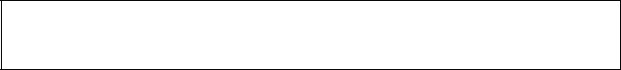

Mark: /47

Overall Level:

Categories | Knowledge | Communication | Thinking/Inquiry/ | Application
 |  |  | Problem Solving
Symbol | K/U | C | T/I | A
Weight | 25 % | 25% | 25 % | 25 %
Mark | /16 | /12 | /14 | /8
Level

pg. 1

Part 1: Knowledge (16 marks)

Multiple choice (10 marks)

1. Which of the following does not have its own metabolism?
a. Eubacteria b. Protista c. Viruses d. Plantae e. Fungi
- Which of the following is not a characteristic of bacterial cells?
  - may be susceptible to antibiotics
  - Could be single-celled
  - Reproduce sexually by binary fission
  - Eukaryotic cell
  - reproduce asexually
- Which of the following is the highest taxonomic level:
a. | Species | b. Genus |  |  | c. Order | d. Kingdom |  | e. Domain
4. During interphase, what form does the genetic material in the cell take?
a. | sister chromatids |  | b. spindle fibres |  |  | c. chromatin | d. homologous chromosome |  |  | e. histone
5. How many chromosomes are found in a human somatic cell?
a. | 6 | b. 32 |  |  | c. 46 | d. 78 |  | e. 23
 | Common Name |  |  |  | Scientific Name |  |  | Family
 | Skip Jack Tuna |  |  |  | Katsuwonus pelamis |  |  | Scombridae
 | Kawaka Tuna |  |  |  | Euthynnus affinis |  |  | Scombridae
 | Pink salmon |  |  |  | Oncorhynchus gorbuscha |  |  | Salmonidae
 |  | Dory |  |  | Zeus faber |  |  | Zeidae
 | Pacific Bonito |  |  |  | Sarda chiliensis |  |  | Scombridae
 | Rainbow trout |  |  |  | Oncorhynchus mykiss |  |  | Salmonidae
 | Atlantic salmon |  |  |  | Salmo salar |  |  | Salmonidae
 | Chub mackerel |  |  |  | Scomber japonicus |  |  | Scombridae

6. Based on the information in the table above, which of the two animals are the most closely related?
a. Skip jack tuna and Kawaka tuna d. Atlantic salmon and Pink salmon
b. Pink salmon and Rainbow trout e. Chub mackerel and Dory
  - Pacific Bonito and Chub mackerel
- What term describes an individual who carries only one type of allele for a gene?
a. heterozygous b. monohybrid c. homozygous d. dihybrid e. none
8. What pattern of heredity is demonstrated when, in shorthorn cattle, a cross between a red bull and a white cow results in roan calves?
a. complete dominance b. incomplete dominance c. X-linked dominance d. codominance e. none

pg. 2

9. What phenotype ratio is expected in a dihybrid cross?
a. 3:1 | b. 1:2:1 | c. 9:3:3:1 | d. 3:1:9 | e. none
- A strand of DNA with the sequence AACTTG will have a complimentary strand with the following sequence:
  - CCAGGT
  - AACTTG
  - TTCAAG
  - TTGAAC
  - none

Matching: (6 marks)

- Binomial nomenclature _____ A two-part key to identify living things.
- Domain _____ A method of naming organisms by using two names (genus & species)
- Phylogeny _____ These organisms lack membrane-bound organelles; prokaryotes.
- Dichotomous key _____ Small particle containing genetic material (DNA/RNA) in a protein capsid
- Bacteria _____ There are 3 of these distinct groups into which all life can be classified.
- Virus _____ The history of the evolution of a species or group of organisms

Short answers:

Part 2: Communication (12 marks)

- (4 marks) Briefly differentiate the following terms.

  - Epidemic and pandemic?

  - Phenotype and genotype?

- (4 marks) Draw a Venn diagram comparing bacteria and Virus. (2 differences for each, and two similarities).

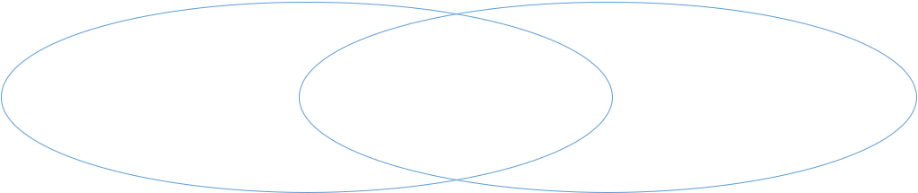

- (4 marks) State the Law of independent assortment.

pg. 3
Part 3: Thinking (14 marks)

- (5 marks) Although viruses are nonliving they cause some severe ailments in humans. Describe how viruses reproduce. In your description explain why sometimes we get the outbreak immediately whereas sometimes we can have a virus but don’t show any symptoms for a long period of time.

(5 marks) Two couples had baby boys in the same hospital at the same time. There was a mix-up in the hospital nursery. Using the information given in the table below, explain which baby belongs to which family. Be sure to include Punnett squares in your answer.

 | Parent 1 | Parent 1 | Parent 2 | Parent 2 | Baby 1 | Baby 2
Blood Type | B | AB | B | A | A | O

Determine the genotypes of the blood types of the parents and babies.

 |  |  |  | Parent 1 |  | Parent 1 |  | Parent 2 |  | Parent 2 |  | Baby 1 |  | Baby 2
 |  | Blood Type |  | B |  | AB |  | B |  | A |  | A |  | O
 |  | Genotype
Use Punnett Squares to determine the possible genotypes of the babies.
 |  |  |  | Couple 1 |  |  |  |  |  |  |  | Couple 2

Therefore, Baby 1 with Type A blood belongs to Couple ______ and Baby 2 with Type O blood

belongs to Couple _______.

- (4 marks) In dogs, there is a hereditary deafness caused by a recessive gene, “d”. A kennel owner has a male dog that she wants to use for breeding purposes. The dog can hear, so the owner knows his genotype is either DD or Dd. If the dog’s genotype is Dd, the owner does not wish to use him for breeding so that the deafness gene will not be passed on. Define test cross. And explain how she can use the results from test cross to determine the genotype of the male dog?

pg. 4
Part 4: Application (8 marks)

- (4 marks) Draw a phytogenic tree by clearly labelling the name of each individual and all characteristics in you diagram.
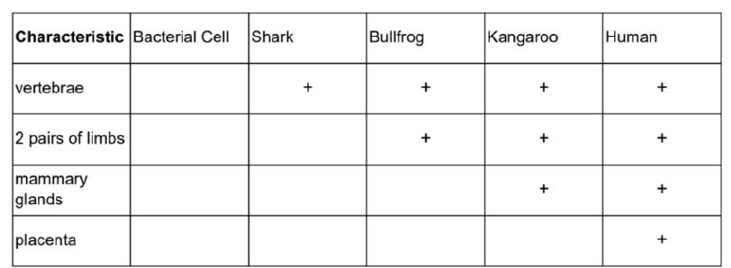

- Erwin Chargaff found that the percentages of adenine and thymine, and guanine and cytosine, in the DNA of organisms are shown in the following Table. Observe the table and answer the following questions.

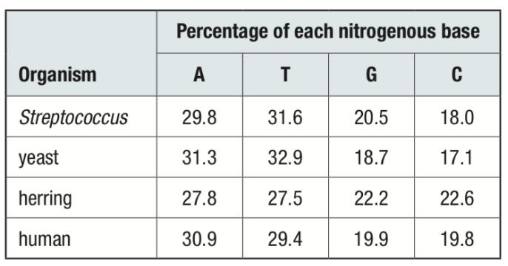

  - (2 marks) If a species has 28% adenine in its DNA, what is the approximate percentage of each of the other three bases in its DNA?

  - (2 marks) What does the fact that the bases adenine and thymine, and guanine and cytosine, occur in such similar percentages suggest about their physical relationships within DNA?

pg. 5

