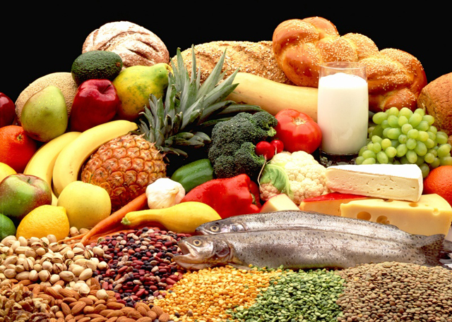
Student Information Sheet
Welcome to Food and Culture (HFC3M)!
By working through this autobiography, you will help me to get to know you and how you write. If you find a question too sensitive to answer please leave the space blank. However, the more you can tell me about yourself, the more I can work to tailor this class to your needs.

Name:

Favourite Season: Food: Subject:

Food and Culture is about:

Three words that describe me:

I would rather: Read Write Watch Discuss

Course Goal and Expected Grade (%):

I wish teachers would

What extracurricular activities are you involved in? (-clubs, sports teams, etc?)

Can you cook? Which food you can cook confidently? Which food recently did you cook for your parents?

Tell me a little bit about your life outside of school (i.e. Do you have a job? Siblings? How do you spend most of your free time?)

What is your “pet peeve”? (-something you really dislike)

What is your favourite thing about school?

What is your least favourite thing about school ?online class

Why are you taking this course? (-give a few reasons for your answer)

What qualities do you have that will contribute to your success in this course? (-attendance, work habits, participation, attitude?)

List any experiences you have had in regards to Food and Culture:

Is there anything else you would like me to know in order for me to best support you this year?

Have a great year! ☺


